CLARIFYING STUDENTS UNDERSTANDING THROUGH THE DESIGN, DEVELOPMENT/CONSTRUCTION, AND UTILIZATION OF A LOCALLY FABRICATED WOODEN VENN DIAGRAM MODEL TO TEACH THE CONCEPTS OF FOOD WEB AND FOOD CHAIN IN BIOLOGY

BY

ADEDOTUN OLUWATOSIN FOLAKE

KWCOED/IL/21/0214

A PROJECT SUBMITTED TO THE DEPARTMENT OF BIOLOGY, KWARA STATE COLLEGE OF EDUCATION, ILORIN
IN PARTIAL FULFILLMENT OF THE REQUIREMENTS FOR AWARD OF NIGERIA CERTIFICATE IN EDUCATION

AUGUST, 2024

CERTIFICATION
This is to certify that the research study was carried out and has been read and approved as meeting the requirement of the department of Biology for the award of Nigeria Certificate in Education (NCE)

Dr. Bello Z.B ____________ __________
Project Supervisor Signature Date

Mr Sadiq H.A ____________ ___________
Head of Department Signature Date

Mr. Ibrahim H.B _____________ __________
Project Co-ordinator Signature Date

DEDICATION
I dedicate this project to my creator. I return all glory and adoration to almighty God for his guideness through the journey of three years he has been my rock, comfort and strength may his name alone be glorify.
ACKNOWLEDGMENTS
I give thanks to almighty God, the magnificent and the merciful. The giver of life, the ultimate for protecting me throughout my course. My special thanks good to my amiable supervisor in person of Dr. Bello Z.A who took time to go through my work and give me useful advice and corrections. Yes sir you are genius and I pray God will bless and reward you. Thank you so much sir.
I am indeed grateful to my parent in person of Mr and Mrs ADEDOTUN for their care. I pray almighty God will protect guide you (Amin). And to my big sister Mrs ISMAIL RUQOYYAT thanks for your support and your provision God will continue to provide for you.
Also to Rev. and Mrs ALADE thanks for your word of encouragement and prayer am very grateful almighty God will guide your families.
Also to my able lecturer in the department of Biology Science in and my able HOD Mr Sadiq H.A may God increase your knowledge sir.

TABLE OF CONTENTS
Title page
Certification 2
Dedication 3
Acknowledgement 4
Table of contents 5
Abstract 6
CHAPTER ONE: INTRODUCTION 7
    - Background of the study
    - Statement of the problem
    - Significant of the study
CHAPTER TWO: REVIEW OR RELATED LITERATURE 11
- Teaching aids are essential tools in the classroom for several reasons. Here are some key points on the needs for teaching aids in class:
- The use of teaching aids in ecology by teachers is crucial for several reasons:
- Popular Misconceptions About Toads and Frogs:
- Why Teachers Must Clear These Misconceptions:
- Danger in Consuming the Wrong One:
- Teaching the concepts related to toads and frogs practically is essential for several reasons:
CHAPTER THREE: METHODOLOGY 19
- Material or tools need to construct the puzzle of human tongue
- Step by step to be followed when constructing
- Recommendations
- Conclusion
Abstract
This project involved the design and construction of a locally made physical model to effectively teach the differences between frogs and toads. The model was developed using easily accessible materials, emphasizing the distinct anatomical features and ecological roles of these amphibians. The primary aim was to enhance student understanding, correct common misconceptions, and promote safe identification practices. The study incorporated hands-on learning activities and assessed the model's effectiveness through student feedback and performance in assessments. Results indicated a significant improvement in student comprehension and engagement, as well as a reduction in misunderstandings about frogs and toads. The model proved to be an effective, cost-efficient teaching tool that can be easily replicated and adapted for use in diverse educational settings.

CHAPTER ONE
INTRODUCTION
Background to the Study
Amphibians, particularly frogs and toads, play a crucial role in ecosystems as both predators and prey, contributing to the balance of natural habitats. Despite their ecological importance, there are widespread misconceptions about these animals, particularly among students. Common myths, such as the belief that toads cause warts or the confusion between frogs and toads, often lead to unnecessary fear, misinformation, and even harmful practices.
In educational settings, the accurate understanding of amphibians is vital not only for biology students but also for fostering a broader appreciation of biodiversity and environmental conservation. Traditional teaching methods, often reliant on textbooks and 2D images, can fall short in conveying the dynamic and complex nature of these animals. Furthermore, the practical aspects of identifying and handling amphibians are difficult to impart through purely theoretical instruction.
Recognizing these challenges, this study was initiated to explore how a physical model, constructed from locally sourced materials, could be used to effectively teach the differences between frogs and toads. The model aimed to provide a hands-on, interactive learning experience that would enhance student engagement, clarify misconceptions, and promote safe identification practices.
By focusing on locally available materials, the project also sought to demonstrate the feasibility of creating cost-effective, sustainable teaching aids that can be easily replicated in schools with limited resources. The model’s development is rooted in the need to improve science education through innovative and practical approaches, ensuring that students not only understand the theoretical concepts but also appreciate the real-world applications and implications of their learning.

This study is set against the backdrop of growing environmental concerns and the need for educational tools that can foster a deeper understanding of and respect for wildlife. By improving how we teach these concepts, we can contribute to better-informed, environmentally conscious future generations.
Research Question:
How can a physical model effectively enhance the understanding of the differences between frogs and toads among students, while addressing common misconceptions and promoting safe practices in identifying and handling these amphibians?
Purpose of the Study:
The purpose of this study is to design, construct, and evaluate a physical model that accurately represents the key anatomical and ecological differences between frogs and toads. The study aims to use this model as an educational tool to improve students' understanding of these amphibians, correct prevalent misconceptions, and promote safe identification and handling practices.
Objectives:
1. To Design and Construct a Physical Model:
- Create a detailed, accurate physical model that highlights the anatomical and ecological differences between frogs and toads.
2. To Evaluate the Effectiveness of the Model in Teaching:
- Assess how effectively the model improves students' understanding of the characteristics, behaviors, and habitats of frogs and toads compared to traditional teaching methods.
3. To Address Common Misconceptions:
- Use the model to correct common misconceptions, such as the belief that toads cause warts or that all frogs and toads are equally poisonous.
4. To Promote Safe Identification and Handling:
- Develop educational materials and activities around the model to teach students how to safely identify and differentiate between frogs and toads, particularly in regions where these animals are consumed or encountered frequently.
5. To Enhance Engagement and Interest in Biology:
- Use the physical model as a tool to increase student engagement and interest in biology, specifically in the study of amphibians and their role in ecosystems.
By achieving these objectives, the study will contribute to more effective teaching practices in biology and foster a deeper appreciation and understanding of amphibians among students.
CHAPTER TWO
LITERATURE REVIEW
Teaching aids are essential tools in the classroom for several reasons. Here are some key points on the needs for teaching aids in class:
1. Enhance Understanding: Teaching aids help clarify complex concepts by providing visual, auditory, or hands-on experiences, making it easier for students to grasp difficult subjects.
2.Engage Students: They capture students' attention and keep them engaged in the lesson, making learning more interactive and enjoyable.
3. Cater to Different Learning Styles: Teaching aids accommodate various learning styles (visual, auditory, kinesthetic), ensuring that all students can benefit from the lesson.
4. Improve Retention: By using teaching aids, students are more likely to remember the information, as these tools reinforce what is being taught through multiple senses.
5. Encourage Participation: Teaching aids often prompt students to participate actively in the lesson, leading to better understanding and retention of the material.
6. Support Inclusive Education: They are crucial for students with special needs, providing alternative ways to learn and understand the material.
7. Facilitate Active Learning: Teaching aids encourage students to explore, ask questions, and interact with the content, promoting active learning rather than passive reception of information.
8. Simplify Complex Information: They break down complicated topics into simpler, more digestible pieces, making it easier for students to follow along and comprehend the subject matter.
Teaching aids are, therefore, critical in creating an effective and dynamic learning environment, ultimately leading to better educational outcomes for students.
The use of teaching aids in ecology by teachers is crucial for several reasons:
1. Visualizing Complex Concepts: Ecology involves understanding complex systems like food chains, energy flow, ecosystems, and biodiversity. Teaching aids such as diagrams, models, and videos help students visualize these concepts, making them easier to comprehend.
2. Field Experience Simulation: Ecology often requires observation and interaction with the natural environment. Teaching aids like virtual labs, 3D models, and interactive simulations allow students to experience and explore ecosystems even when field trips are not possible.
3. Engagement with Real-World Examples: Teaching aids like documentaries, case studies, and real-life examples of ecological phenomena can make lessons more relatable and engaging, helping students see the relevance of ecology to their daily lives.
4. Hands-on Learning: Teaching aids such as soil samples, water testing kits, and plant specimens enable hands-on learning, allowing students to conduct experiments and observe ecological processes directly.
5. Supporting Diverse Learning Styles: Ecology involves a mix of visual, auditory, and kinesthetic information. Teaching aids can cater to these diverse learning styles, ensuring all students grasp ecological concepts effectively.
6. Illustrating Ecological Interactions: Ecology is all about interactions within ecosystems. Teaching aids like flowcharts, interactive maps, and animation can illustrate these interactions clearly, showing how changes in one part of the system can affect the whole.
7. Encouraging Critical Thinking: Using teaching aids, such as problem-solving activities, simulations, and ecological games, can encourage students to think critically about environmental issues and the impact of human activities on ecosystems.
8. Promoting Environmental Awareness: Teaching aids that highlight ecological challenges, like deforestation, climate change, and pollution, can foster a sense of responsibility and encourage students to adopt sustainable practices.
By integrating teaching aids into ecology lessons, teachers can create a more effective, engaging, and comprehensive learning experience that helps students understand and appreciate the intricate balance of our natural world.
Popular Misconceptions About Toads and Frogs:
1.Confusing Toads with Frogs: Many people think that toads and frogs are the same and use the terms interchangeably. However, they are different types of amphibians with distinct characteristics.
2. Toads Cause Warts: A common myth is that touching a toad can give you warts. This is not true; warts are caused by a virus and cannot be contracted from toads.
3. Frogs Are Always Slimy and Wet: People often believe that all frogs are slimy and live in water. While many frogs have moist skin, not all frogs are slimy, and some can live in dry environments.
4. All Frogs and Toads Are Poisonous: While some species of frogs and toads secrete toxins as a defense mechanism, not all are poisonous, and those that are usually pose little danger to humans unless ingested or mishandled.
Why Teachers Must Clear These Misconceptions:
1. Correct Knowledge: Ensuring students understand the differences between frogs and toads helps in promoting accurate biological knowledge and understanding of biodiversity.
2. Encouraging Respect for Wildlife: Clearing up misconceptions fosters a better respect and appreciation for amphibians, which are important indicators of environmental health.
3. Avoiding Fear and Misinformation: Many myths, like toads causing warts, can lead to unnecessary fear or even harm to these creatures. Teachers can help students overcome irrational fears by providing correct information.
4. Promoting Conservation: Misunderstanding amphibians can lead to negative attitudes toward them, potentially harming conservation efforts. Accurate knowledge can encourage students to protect these vital species.
Danger in Consuming the Wrong One:
1. Toxicity: Some toads, particularly the Cane Toad (Rhinella marinan, secrete potent toxins from their skin that can be harmful or even fatal if ingested by humans or animals. Consuming a poisonous toad can lead to serious health issues such as nausea, vomiting, seizures, or death.
2. Misidentification: People may mistakenly consume toxic toads thinking they are frogs, which can be a dangerous mistake. Teachers need to educate students on how to correctly identify amphibians to prevent such errors.
3. Cultural Practices: In some cultures, frogs are consumed as food. It’s essential for people to understand the differences between safe and unsafe species to avoid the dangers of poisoning.
By addressing these misconceptions, teachers play a vital role in ensuring that students understand the importance of amphibians, can differentiate between frogs and toads, and are aware of the risks associated with consuming the wrong species.
Teaching the concepts related to toads and frogs practically is essential for several reasons:
1. Enhancing Understanding Through Direct Observation:
- Real-Life Experience: When students observe frogs and toads directly, they can see the differences in their physical characteristics, such as skin texture, color, and body shape, which reinforces theoretical knowledge.
- Active Learning: Practical lessons allow students to engage with the material more actively, making it easier to understand and retain information.
2. Correcting Misconceptions:
- Hands-On Clarification: By handling live or preserved specimens under supervision, students can see for themselves that toads do not cause warts, which directly addresses and dispels common myths.
- Real Examples: Showing the distinction between toxic and non-toxic species in a controlled environment helps students understand the real dangers and avoid misinformation.
3. Promoting Critical Thinking:
- Field Investigations: Practical activities such as pond dipping or exploring local habitats can encourage students to observe and question the behaviors and environments of amphibians, fostering critical thinking skills.
- Analysis of Specimens: Students can learn to analyze and classify amphibians based on observed characteristics, which helps in developing analytical skills and scientific reasoning.
4. Encouraging Respect for Wildlife:
- Building Empathy: When students interact with live animals or their habitats, they are more likely to develop empathy and a sense of responsibility for the conservation of these species.
- Understanding Ecology: Practical lessons help students see the role of frogs and toads in ecosystems, such as their part in controlling insect populations, which promotes environmental stewardship.
5. Preventing Harmful Mistakes:
- Safe Identification: Practical training in identifying frogs and toads ensures that students can distinguish between species, preventing harmful mistakes like consuming toxic toads.
- Real-World Application: Understanding these distinctions has real-world implications, particularly in regions where frogs and toads are consumed, ensuring that students can apply their knowledge safely.
6. Engaging All Learning Styles:
- Visual and Kinesthetic Learning: Practical activities cater to students who learn best through seeing and doing, ensuring that all students, regardless of learning style, can grasp the material effectively.
7. Fostering a Love for Science:
- Interactive Learning: Practical lessons are often more engaging and enjoyable, which can spark a lifelong interest in biology and the natural world.
By teaching these concepts practically, educators can provide a deeper, more comprehensive understanding of amphibians, correct misconceptions, and equip students with the knowledge and skills they need to engage with the natural world safely and respectfully.

CHAPTER THREE
METHODOLOGY
Steps in making the instructional material
Creating a visual display of food webs and food chains
- Step 1: Purchased a medium density fiberboard (MDF) board which is a type of flat, smooth board used for various projects
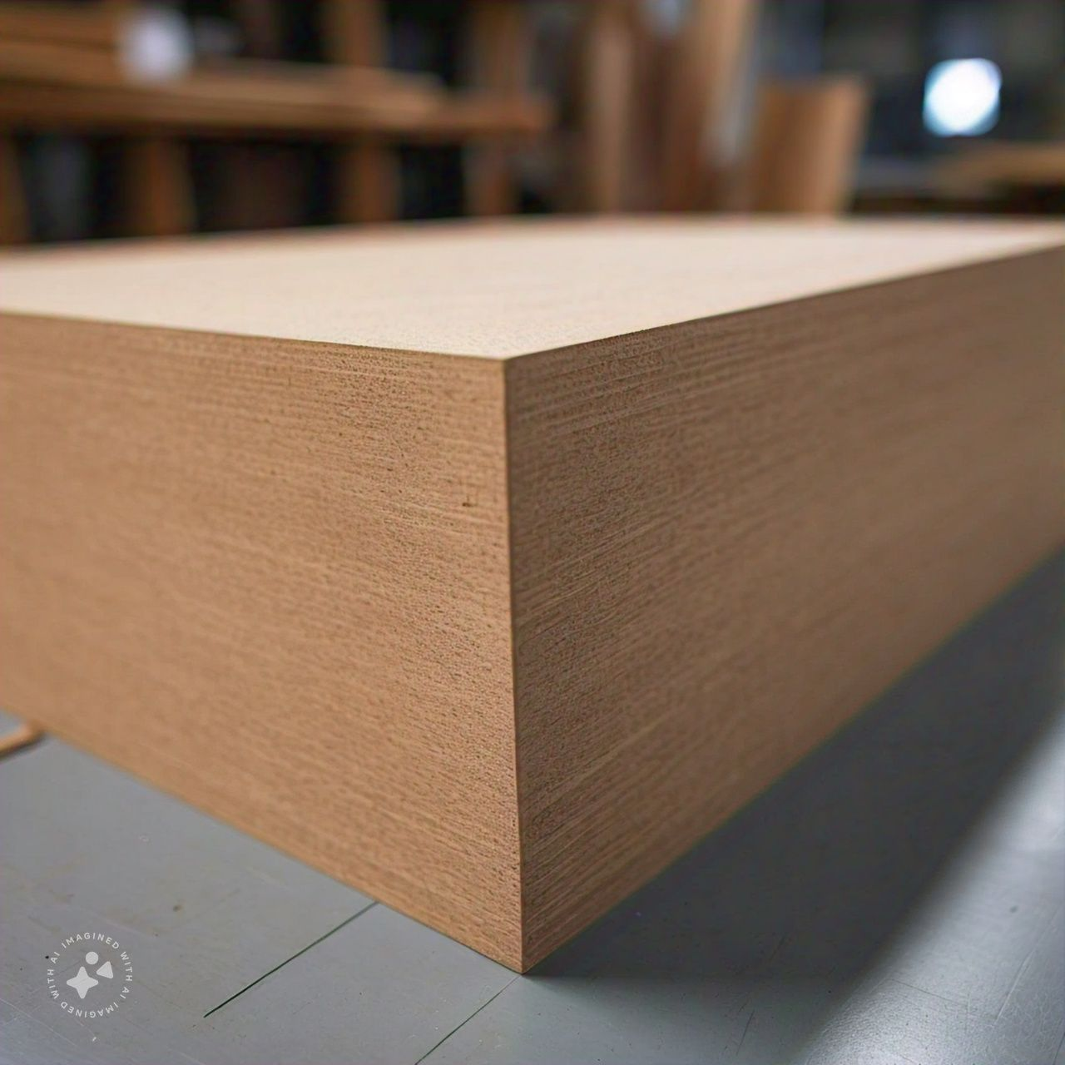
- Step 2: took the (MDF) board to professional furniture maker or carpenter likely to have them work on the board

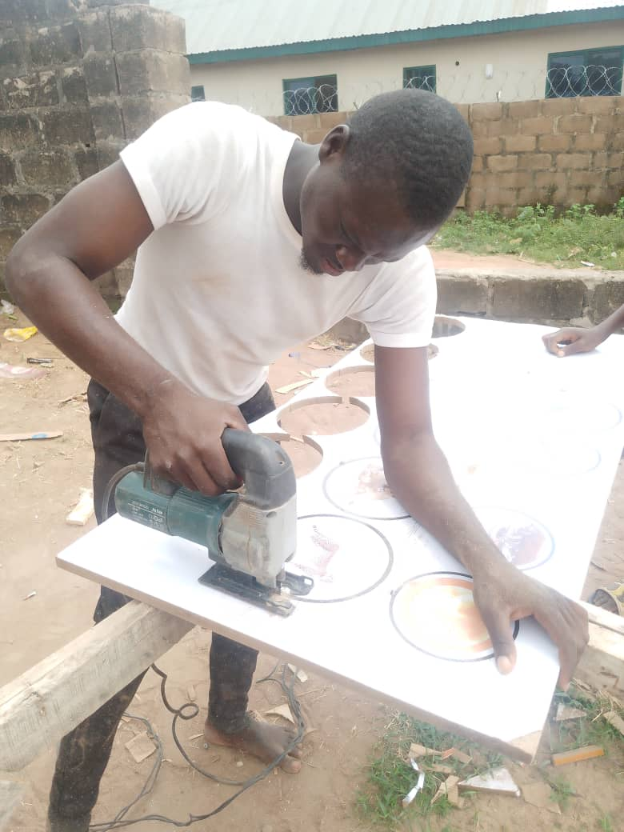
- Step 3: The furniture maker applied a printed image or design of food webs and food chains onto the MDF board using a plastering or mounting techniques. This step likely involved a teaching the printed image to the board

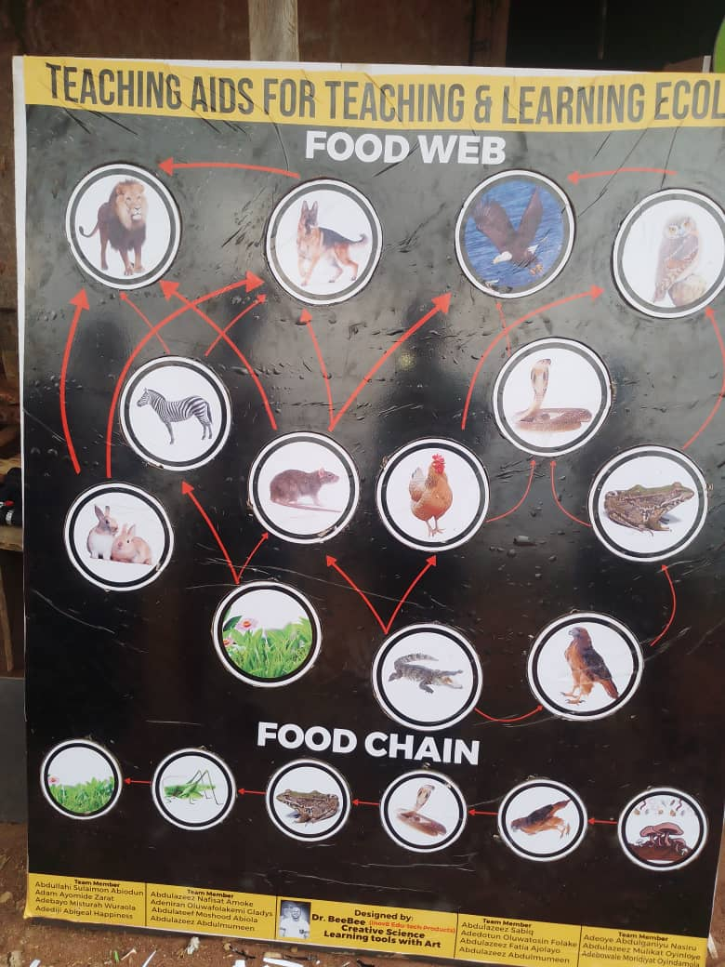
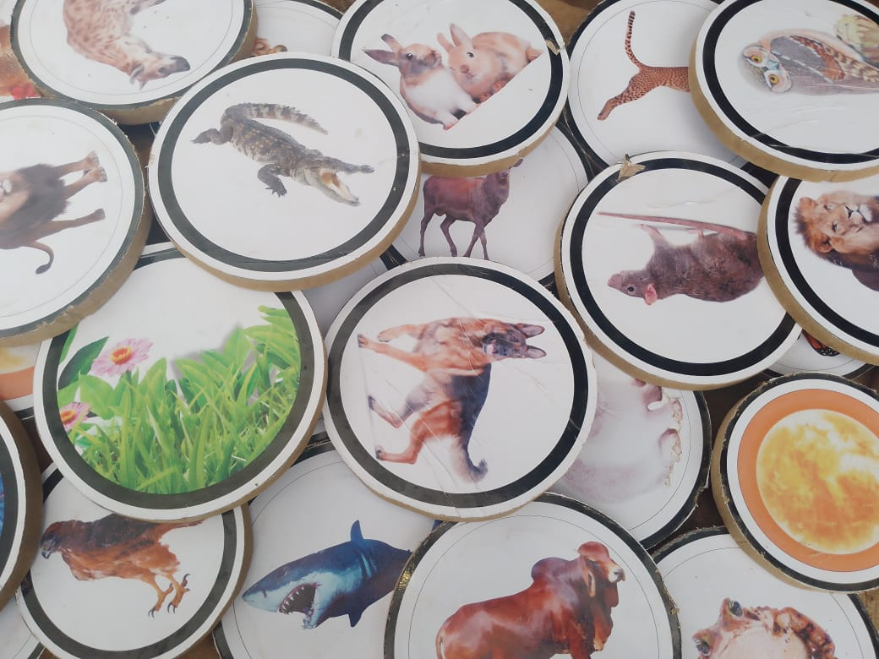
- Step 4: it removed any excess pr circular cutout from the printed image of the food webs and food chains. This step might involves trimming or cutting away excess material or shapes that weren’t part of the main design
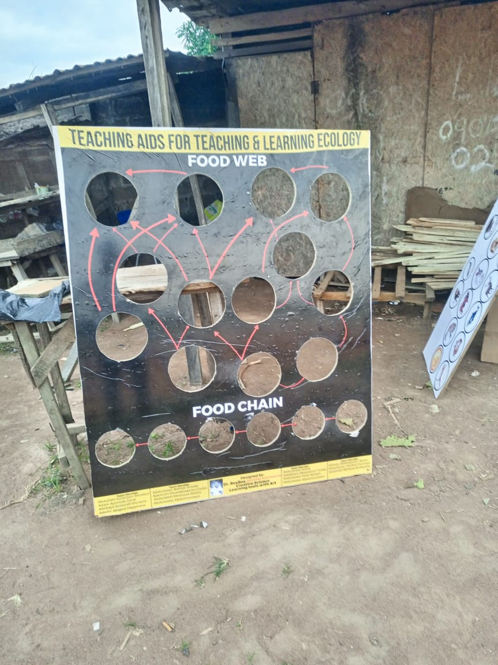

- Step 5: its reviewed display to ensure the food webs and food chain were accurate represented and clearly visible
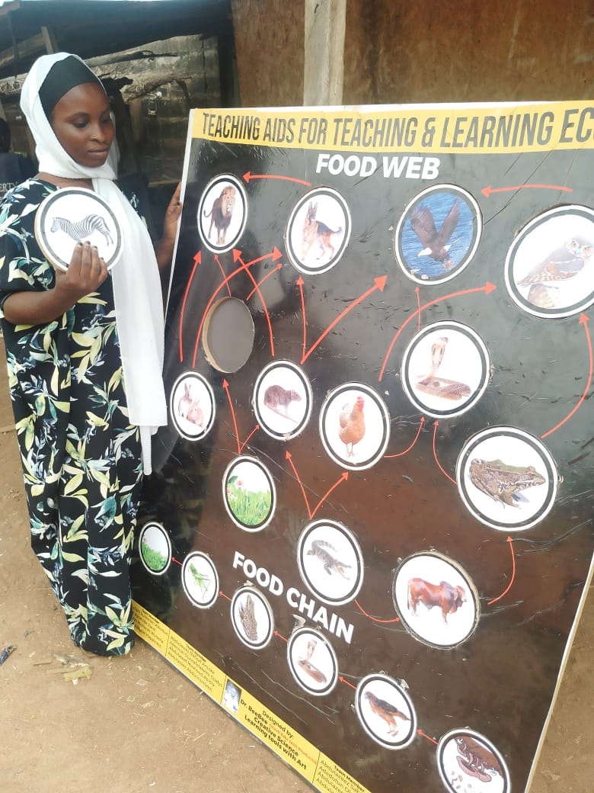
- Step 6: it added any additional features such as labels, arrows, or descriptive to enhance the display and facilitate understanding
- Step 7: its sealed or protected the display to prevent damage or ear, possible using a varnish or laminate
- Step 8: it installed or mounted the display in a suitable location, such as a classroom, office or exhibit space
- Step 9: Attach another MDF board to the back of the original MDF board to the back of the original board using screws, nails or a strong ashensive. This will provide additional support and ensure the display remain flat and secure
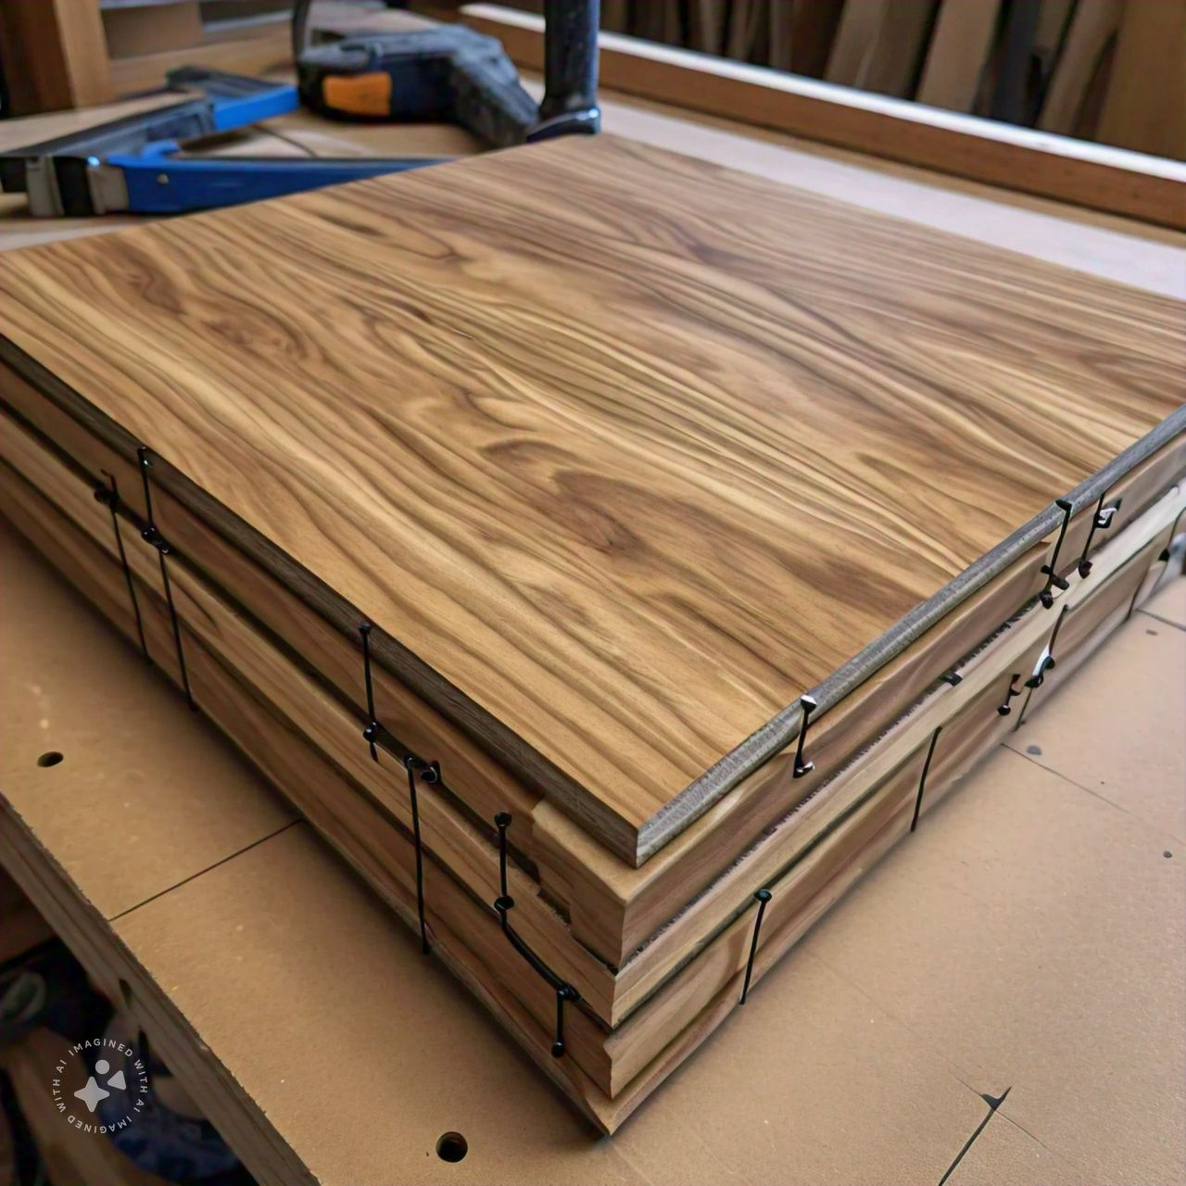
- Step 10: design and build a stand for the display, allowing it to be carried and show cased in an upright position. The stand can be made from materials like wood, metal or plastic, and can be attached to the MDF board using screw, nails or adhesive


With the stand you’ll be able to”
- Easily transport to display to different locations
- Showcase the food web and food chain display in a prominent and visible ways
- Adjust the display to different angles or heights as needed
Recommendations:
1. Wider Implementation: It is recommended that the locally made physical model be incorporated into biology curricula across various educational levels to improve understanding of amphibian species and their ecological importance.
2.Teacher Training: Teachers should receive training on how to effectively use the model in their classrooms, including strategies for integrating it into existing lesson plans and engaging students in hands-on activities.
3. Development of Supplementary Materials: Additional teaching aids, such as interactive digital content or worksheets, should be developed to complement the physical model, ensuring that different learning styles are accommodated.
4. Periodic Review and Improvement: The model should be periodically reviewed and updated based on student feedback and advances in ecological education to ensure it remains relevant and effective.
5. Community Engagement: Schools should involve local communities in the project by organizing workshops or demonstrations to raise awareness about amphibian conservation and the importance of correct identification.

Conclusion:
The construction and use of a locally made physical model for teaching the differences between frogs and toads have proven to be a valuable educational tool. The project successfully enhanced students' understanding, corrected common misconceptions, and promoted safe practices in amphibian identification. The use of locally sourced materials not only made the model cost-effective but also demonstrated the feasibility of utilizing indigenous resources in educational innovations. The positive feedback from students and teachers alike suggests that this approach

