CLARIFYING STUDENTS UNDERSTANDING THROUGH THE DESIGN, DEVELOPMENT/CONSTRUCTION, AND UTILIZATION OF A LOCALLY FABRICATED WOODEN MODEL TO TEACH THE CONCEPTS OF ECOLOGY (FOOD WEB & FOOD CHAIN) IN BIOLOGY

BY

ABDULAZEEZ ABDULMUMEEN

KWCOED/21/0567

A PROJECT SUBMITTED TO THE DEPARTMENT OF CHEMISTRY, KWARA STATE COLLEGE OF EDUCATION, ILORIN
IN PARTIAL FULFILLMENT OF THE REQUIREMENTS FOR AWARD OF NIGERIA CERTIFICATE IN EDUCATION

AUGUST, 2024

CERTIFICATION
This is to certify that the research study was carried out and has been read and approved as meeting the requirement of the department of Maths/Chem for the award of Nigeria Certificate in Education (NCE)

Dr. Mrs. V.O. Babatunde ____________ __________
Project Supervisor Signature Date

Sadiq H.A ____________ ___________
Head of Department Signature Date

Mr. Ibrahim H.B _____________ __________
Project Co-ordinator Signature Date

DEDICATION
I dedicate this project to my creator
ACKNOWLEDGMENTS
I give thanks to almighty Allah, the magnificent and the merciful. The giver of life, the ultimate for protecting me throughout my course. My special thanks good to my amiable supervisor in person of Dr. Bello Z.A who took time to go through my work and give me useful advice and corrections. Yes sir you are genius and I pray God will bless and reward you. Thank you so much sir.
I am indeed grateful to my parent in person of Mr and Mrs ABDULAZEEZ for their care. I pray almighty God will protect guide you (Amin)
Also to my able lecturer in the department of Maths/Chem in and my able Dr. Mrs. V.O. Babatunde may God increase your knowledge sir.

TABLE OF CONTENTS
Title page
Certification 2
Dedication 3
Acknowledgement 4
Table of contents 5
Abstract 6
CHAPTER ONE: INTRODUCTION 7
    - Background of the study
    - Statement of the problem
    - Significant of the study
CHAPTER TWO: REVIEW OR RELATED LITERATURE 11
- Teaching aids are essential tools in the classroom for several reasons. Here are some key points on the needs for teaching aids in class:
- The use of teaching aids in ecology by teachers is crucial for several reasons:
CHAPTER THREE: METHODOLOGY 19
- Material or tools need to construct the model
- Step by step to be followed when constructing
- Recommendations
- Conclusion
Abstract
This study focuses on the design, development, and utilization of a locally fabricated wooden model to teach ecological concepts, specifically the food web and food chain, in biology. The project was undertaken to address common misconceptions and enhance students' understanding of these fundamental ecological relationships. The wooden model was designed to provide a hands-on, interactive learning experience, allowing students to visualize the connections between organisms and the flow of energy within ecosystems. The model was developed using locally sourced materials to ensure affordability and accessibility in resource-limited educational settings. Through practical activities, the study assessed the model's effectiveness by evaluating student engagement, comprehension, and performance in assessments. Results indicated significant improvements in students' grasp of the concepts of food chains and food webs, demonstrating that the locally fabricated wooden model serves as an effective instructional tool that can be easily replicated in other educational contexts.

CHAPTER ONE
INTRODUCTION
Background to the Study
The teaching of science subjects, particularly biology, plays a crucial role in fostering critical thinking, problem-solving, and environmental awareness among students. Biology, being a subject rooted in the understanding of living organisms and their interactions, is essential for developing students' knowledge of the natural world. One key area of focus in biology education is ecology, where concepts such as food chains and food webs are central to understanding the relationships between organisms and their environments. However, many students struggle to grasp these interconnected ecological relationships, leading to misconceptions and superficial understanding.
Teaching abstract ecological concepts like food chains and food webs poses significant challenges. Traditional methods, such as textbook reading or lecture-based instruction, often fail to provide students with the deep understanding required to differentiate between complex biological interactions. This lack of comprehension is further exacerbated by the limitations of available instructional materials. For many schools, especially in developing countries like Nigeria, access to high-quality teaching aids and models is limited, resulting in an over-reliance on rote memorization rather than conceptual understanding. Consequently, students often find it difficult to visualize and analyze ecological processes, leading to misconceptions that persist into higher levels of education.

To address these challenges, educational research has increasingly emphasized the importance of active learning strategies and the use of instructional models in science teaching. Active learning, which includes hands-on activities, problem-solving tasks, and cooperative learning, has been shown to enhance students' engagement and understanding of complex concepts. Similarly, the use of physical models has proven to be an effective way of breaking down abstract scientific concepts into manageable, visual representations that students can easily interact with and understand. By allowing students to manipulate models and see tangible representations of theoretical ideas, teachers can create a more effective learning environment where concepts like food chains and food webs become easier to comprehend.
In many Nigerian classrooms, however, there is a shortage of effective instructional aids that can help illustrate such concepts. This challenge highlights the need for the development of locally fabricated teaching models that can be easily constructed using accessible materials. Not only do such models provide cost-effective solutions, but they also promote the development of innovative teaching practices that can enhance students’ learning experiences. By creating a wooden Venn diagram model to teach food chains and food webs, this study seeks to provide a practical, hands-on learning tool that can bridge the gap between abstract ecological theory and students' understanding.

This study is grounded in the educational theories of constructivism and active learning. Constructivism, a theory developed by Jean Piaget, emphasizes that students build their own understanding and knowledge of the world through experiences and reflecting on those experiences. Active learning strategies, which align with this theory, support students' engagement in the learning process by encouraging them to actively participate in the construction of knowledge. When students use physical models, such as the wooden Venn diagram in this study, they are engaging in an interactive learning process that helps them build a deeper understanding of ecological relationships.
Given the importance of ecology in understanding environmental issues and sustainability, it is crucial that students develop a strong foundation in ecological concepts. By enhancing their comprehension of food chains and food webs, students can develop a broader understanding of how ecosystems function, which can, in turn, foster a deeper appreciation for environmental conservation and sustainability. Moreover, the ability to use hands-on models aligns with Nigeria’s curriculum reform initiatives that focus on improving STEM (Science, Technology, Engineering, and Mathematics) education. Introducing innovative and locally made teaching tools such as this wooden Venn diagram can also contribute to the development of entrepreneurship skills in the education sector, aligning with Nigeria’s goals of fostering educational self-reliance and sustainability.
In conclusion, this study aims to address the existing gaps in teaching aids for ecology by designing, developing, and utilizing a locally fabricated wooden model to teach food chains and food webs. By providing a hands-on, interactive tool, the study seeks to enhance student understanding, reduce misconceptions, and improve engagement in learning these fundamental ecological concepts. Ultimately, this research contributes to the ongoing conversation about the need for innovative, accessible, and effective teaching resources in biology education, particularly in contexts with limited access to high-quality instructional materials.
Purpose of the Study:
The primary purpose of this study is to design, develop, and utilize a locally fabricated wooden model as a teaching tool to improve students’ understanding of the concepts of food chains and food webs in ecology. Specifically, the study aims to:
1. Enhance Student Comprehension: By providing a hands-on, visual representation of the differences and similarities between food chains and food webs, the model seeks to facilitate deeper student understanding of these fundamental ecological concepts.
2. Correct Common Misconceptions: The study aims to address and correct common misconceptions students have about food chains and food webs, offering clearer distinctions between these ecological processes through interactive learning.

3. Improve Engagement in Learning: The project intends to promote active learning by involving students in manipulating the wooden Venn diagram model during lessons, thereby improving their engagement, motivation, and interest in ecology.
4. Provide a Cost-Effective Teaching Tool: The study aims to demonstrate that effective, low-cost teaching aids can be developed using locally sourced materials, providing a solution for schools with limited access to commercial instructional models.
5. Evaluate the Effectiveness of the Model: Through student feedback and performance assessments, the study seeks to evaluate the effectiveness of the wooden Venn diagram model in improving understanding and retention of ecological concepts compared to traditional teaching methods.
By achieving these objectives, the study ultimately seeks to contribute to more effective and innovative biology teaching practices, with the potential for broader application in educational settings with limited resources.
Objectives of the Study
The objectives of this study are to:
1. Design and construct a locally fabricated wooden Venn diagram model to visually compare and contrast the concepts of food chains and food webs in ecology.

2. Utilize the wooden Venn diagram model as a hands-on teaching tool to enhance students’ understanding of the ecological relationships within food chains and food webs.
3. Assess the impact of the model on student comprehension of the differences between food chains and food webs by comparing their performance before and after its use in the classroom.
4. Evaluate the effectiveness of the model in correcting misconceptions related to food chains and food webs through student feedback and engagement during the learning process.
5. Promote active learning by involving students in interactive activities with the model, encouraging participation and improving retention of the key ecological concepts.
6. Determine the cost-effectiveness and practicality of the model for use in schools, particularly in resource-limited educational settings, to provide an affordable and replicable teaching aid for biology instruction.
7. Encourage the development of innovative teaching aids using locally sourced materials, fostering a culture of creativity and entrepreneurship within the educational sector.
Definition of Key Terms
1. Venn Diagram: A graphical representation used to show the relationships between different sets. In this study, the Venn diagram will visually depict the similarities and differences between food chains and food webs.

2. Food Chain: A linear sequence of organisms where each is dependent on the next for food, showing how energy flows from one organism to another in an ecosystem.
3. Food Web: A complex network of interconnected food chains within an ecosystem, showing the various feeding relationships among organisms and how energy is transferred in multiple directions.
4. Ecology: The branch of biology that studies the interactions between living organisms and their environment, including the relationships between organisms and their ecosystems.
5. Locally Fabricated Model: A teaching aid designed and constructed using materials readily available within a specific locality. In this study, the model refers to a wooden Venn diagram created to teach biological concepts.
6. Active Learning: A student-centered approach to education that involves engaging students in activities, discussions, and hands-on experiences to promote deeper learning and better retention of information.
7. Misconception: An incorrect understanding or interpretation of a concept. In this context, it refers to students' misunderstandings of the differences and connections between food chains and food webs.
8. Comprehension: The ability to understand and grasp the meaning of something. Here, it refers to the students' understanding of ecological concepts like food chains and food webs.

9. Hands-On Learning: A teaching approach where students learn by doing and directly interacting with materials, models, or experiments, as opposed to passively receiving information.
10. Cost-Effective: An economical approach that achieves the desired outcome without requiring a significant financial investment. The term is used here to describe the affordability of the wooden Venn diagram model as a teaching aid.
11. Teaching Tool: Any material, device, or strategy used to facilitate teaching and improve learning outcomes. In this study, the wooden Venn diagram model serves as the teaching tool for conveying ecological concepts.
12. Student Engagement: The level of interest, enthusiasm, and involvement that students show in the learning process. This study aims to increase engagement through the use of the interactive Venn diagram model.

CHAPTER TWO
LITERATURE REVIEW
introduction

The teaching of ecological concepts such as food chains and food webs forms a crucial component of biology education at various levels of schooling. These concepts help students understand the relationships and energy flow between organisms in ecosystems. However, teaching these abstract ideas in a way that promotes deep understanding can be challenging, particularly in environments where students struggle to visualize and grasp complex ecological interactions. This difficulty is often compounded by the lack of adequate teaching resources and instructional materials, particularly in resource-limited settings like many schools in Nigeria.
In this context, the use of concrete instructional materials has been widely advocated as an effective pedagogical strategy for enhancing students’ comprehension. Concrete models and teaching aids provide visual and tactile experiences that aid in translating abstract ecological concepts into understandable terms. This review explores existing literature on the importance of teaching food chains and food webs in schools and highlights the significant role that concrete instructional materials play in facilitating students' understanding of these essential ecological concepts.

Teaching aids are essential tools in the classroom for several reasons. Here are some key points on the needs for teaching aids in class:
1. Enhance Understanding: Teaching aids help clarify complex concepts by providing visual, auditory, or hands-on experiences, making it easier for students to grasp difficult subjects.
2.Engage Students: They capture students' attention and keep them engaged in the lesson, making learning more interactive and enjoyable.
3. Cater to Different Learning Styles: Teaching aids accommodate various learning styles (visual, auditory, kinesthetic), ensuring that all students can benefit from the lesson.
4. Improve Retention: By using teaching aids, students are more likely to remember the information, as these tools reinforce what is being taught through multiple senses.
5. Encourage Participation: Teaching aids often prompt students to participate actively in the lesson, leading to better understanding and retention of the material.
6. Support Inclusive Education: They are crucial for students with special needs, providing alternative ways to learn and understand the material.
7. Facilitate Active Learning: Teaching aids encourage students to explore, ask questions, and interact with the content, promoting active learning rather than passive reception of information.
8. Simplify Complex Information: They break down complicated topics into simpler, more digestible pieces, making it easier for students to follow along and comprehend the subject matter.
Teaching aids are, therefore, critical in creating an effective and dynamic learning environment, ultimately leading to better educational outcomes for students.
The use of teaching aids in ecology by teachers is crucial for several reasons:
1. Visualizing Complex Concepts: Ecology involves understanding complex systems like food chains, energy flow, ecosystems, and biodiversity. Teaching aids such as diagrams, models, and videos help students visualize these concepts, making them easier to comprehend.
2. Field Experience Simulation: Ecology often requires observation and interaction with the natural environment. Teaching aids like virtual labs, 3D models, and interactive simulations allow students to experience and explore ecosystems even when field trips are not possible.
3. Engagement with Real-World Examples: Teaching aids like documentaries, case studies, and real-life examples of ecological phenomena can make lessons more relatable and engaging, helping students see the relevance of ecology to their daily lives.
4. Hands-on Learning: Teaching aids such as soil samples, water testing kits, and plant specimens enable hands-on learning, allowing students to conduct experiments and observe ecological processes directly.
5. Supporting Diverse Learning Styles: Ecology involves a mix of visual, auditory, and kinesthetic information. Teaching aids can cater to these diverse learning styles, ensuring all students grasp ecological concepts effectively.
6. Illustrating Ecological Interactions: Ecology is all about interactions within ecosystems. Teaching aids like flowcharts, interactive maps, and animation can illustrate these interactions clearly, showing how changes in one part of the system can affect the whole.
7. Encouraging Critical Thinking: Using teaching aids, such as problem-solving activities, simulations, and ecological games, can encourage students to think critically about environmental issues and the impact of human activities on ecosystems.
8. Promoting Environmental Awareness: Teaching aids that highlight ecological challenges, like deforestation, climate change, and pollution, can foster a sense of responsibility and encourage students to adopt sustainable practices.
By integrating teaching aids into ecology lessons, teachers can create a more effective, engaging, and comprehensive learning experience that helps students understand and appreciate the intricate balance of our natural world
The Importance of Teaching Food Chains and Food Webs in Schools
Food chains and food webs are fundamental ecological concepts that describe how organisms are interconnected within ecosystems. A food chain represents a linear sequence of organisms, each serving as food for the next, while food webs depict the complex network of feeding relationships among various species within an ecosystem. These concepts help students understand how energy flows through ecosystems, from producers to consumers, and the crucial role each organism plays in maintaining ecological balance.
Understanding food chains and food webs is not only essential for biology education but also contributes to students' broader environmental awareness. As the world faces increasing environmental challenges such as biodiversity loss, habitat destruction, and climate change, it is imperative that students develop a solid understanding of how ecosystems function. This knowledge equips them with the skills and awareness to make informed decisions about environmental conservation and sustainability. Therefore, teaching these concepts in schools is crucial for fostering a generation of environmentally literate citizens who can contribute to the protection and restoration of ecosystems.

Despite the importance of these concepts, studies have shown that students often struggle to fully grasp the differences between food chains and food webs, as well as the energy flow that underpins these ecological processes. According to researchers like Carlsson (2002) and Hogan (2000), many students enter biology classrooms with pre-existing misconceptions about ecosystems that hinder their ability to understand ecological relationships correctly. These misconceptions often include the belief that food chains are independent entities rather than interconnected parts of a broader food web, or that energy flow in ecosystems is circular rather than unidirectional. Addressing these misconceptions requires effective teaching strategies, including the use of instructional materials that can make these abstract ideas more tangible for students.
Challenges in Teaching Food Chains and Food Webs
One of the major challenges in teaching ecological concepts like food chains and food webs is their inherent complexity and abstract nature. Students are required to understand how multiple organisms are interconnected, how energy flows from one trophic level to another, and how disruptions in one part of an ecosystem can have cascading effects on the entire system. While textbooks and lectures provide theoretical knowledge, they often fail to engage students in ways that lead to deep, lasting understanding.
Moreover, many students struggle with visualizing the dynamic nature of ecosystems. Traditional teaching methods, such as drawing food chains or food webs on the board, do not offer students the interactive experience needed to see these ecological relationships in action. Research by Brody and Tomkiewicz (2002) highlights that passive learning methods, where students merely observe or read about ecological concepts, result in superficial understanding and retention. In contrast, when students actively engage with concrete representations of these concepts, they are more likely to internalize and retain the knowledge.
Furthermore, a significant gap exists between the curriculum requirements and the availability of effective teaching resources in many schools, especially in under-resourced regions. This lack of resources often limits teachers’ ability to provide students with the interactive, hands-on experiences that have been shown to enhance learning. A study by Adewale and Akintayo (2019) on the state of biology teaching in Nigeria reported that many schools lack even basic instructional materials, forcing teachers to rely on traditional lecture methods that do little to foster deep comprehension of complex topics like food webs and chains.
The Need for Concrete Instructional Materials
Concrete instructional materials—such as physical models, diagrams, and manipulatives—are widely recognized as effective tools for teaching abstract scientific concepts. These materials serve to bridge the gap between theory and practice by providing students with tangible representations of the concepts being taught. In the context of teaching food chains and food webs, concrete instructional materials allow students to physically manipulate models, see the flow of energy between organisms, and better understand the hierarchical structure of ecosystems.

Research has consistently shown that students who engage with concrete materials develop a deeper understanding of scientific concepts than those who rely solely on abstract learning methods. According to Piaget’s theory of cognitive development (Piaget, 1970), students, particularly at the secondary school level, benefit from learning that involves concrete operational thinking, where they can physically manipulate objects to learn new concepts. Concrete models allow students to move beyond rote memorization and engage in active learning, fostering critical thinking and problem-solving skills.
Furthermore, the construction of locally fabricated instructional models offers several advantages in resource-limited settings. Locally sourced materials are cost-effective and readily available, making it feasible for schools with limited budgets to create and implement such teaching aids. This aligns with the broader push towards education sustainability, where schools are encouraged to use locally available resources to enhance teaching and learning. The development of these materials also fosters creativity and innovation among teachers, encouraging them to think critically about how to adapt instructional strategies to meet the specific needs of their students.
Effectiveness of Concrete Instructional Materials
The effectiveness of concrete instructional materials in teaching ecological concepts is supported by numerous studies. For instance, a study by Novak and Gowin (2006) demonstrated that using models to represent food webs significantly improved students’ understanding of energy transfer within ecosystems. Students who interacted with physical models performed better in assessments, retained information longer, and exhibited a more profound understanding of how species interactions shape ecosystems.
Similarly, research by Etim and Nse (2016) on the use of instructional materials in teaching biology in Nigerian secondary schools revealed that students taught with concrete models showed a marked improvement in their comprehension of complex biological concepts, including food chains and food webs. Their study emphasized that these materials provided students with an engaging and memorable learning experience, leading to better academic performance and deeper conceptual understanding.
Additionally, concrete instructional materials provide an opportunity for differentiated learning, where students with varying abilities and learning styles can engage with the content in ways that suit their needs. Visual learners, for example, benefit greatly from seeing diagrams and models, while kinesthetic learners gain understanding by physically manipulating objects. This inclusive approach to teaching ensures that all students have an opportunity to grasp difficult concepts, regardless of their preferred learning style.
Conusion
The teaching of food chains and food webs is essential for students to understand the intricate relationships within ecosystems and the flow of energy that sustains life. However, traditional teaching methods often fail to convey the complexity of these concepts effectively. The use of concrete instructional materials, such as locally fabricated models, can significantly enhance students' understanding of these ecological relationships by providing them with interactive, hands-on learning experiences.
Given the documented benefits of concrete models in science education, it is clear that integrating such tools into the teaching of food chains and food webs will not only improve comprehension but also foster a deeper appreciation for ecological systems. This is particularly important in contexts where access to commercial teaching aids is limited, as locally fabricated materials provide an affordable and sustainable solution for improving science education.
In light of these findings, this study aims to develop and implement a locally fabricated wooden Venn diagram model to teach food chains and food webs, providing students with an effective, cost-efficient tool for enhancing their understanding of these critical ecological concepts.

.
CHAPTER THREE
METHODOLOGY
Steps in making the instructional material
Creating a visual display of food webs and food chains
- Step 1: Purchased a medium density fiberboard (MDF) board which is a type of flat, smooth board used for various projects

- Step 2: took the (MDF) board to professional furniture maker or carpenter likely to have them work on the board

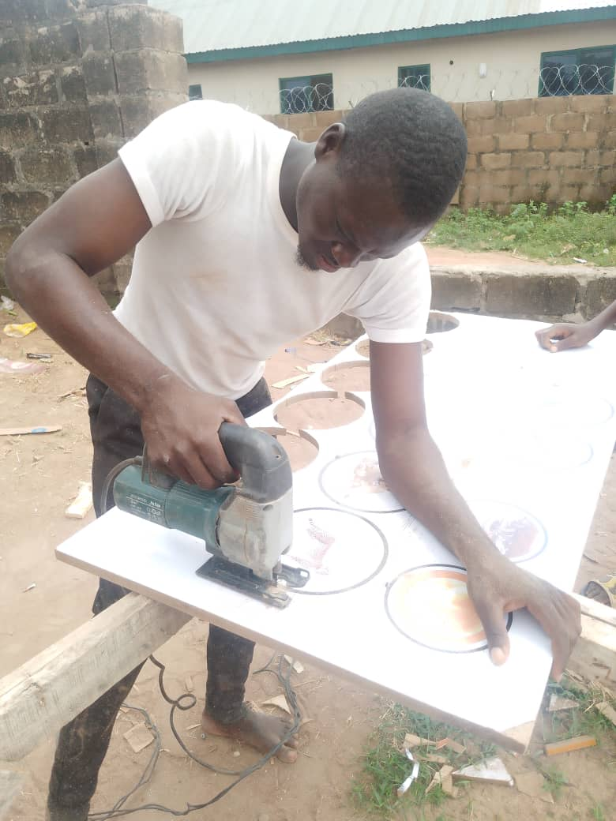
- Step 3: The furniture maker applied a printed image or design of food webs and food chains onto the MDF board using a plastering or mounting techniques. This step likely involved a teaching the printed image to the board

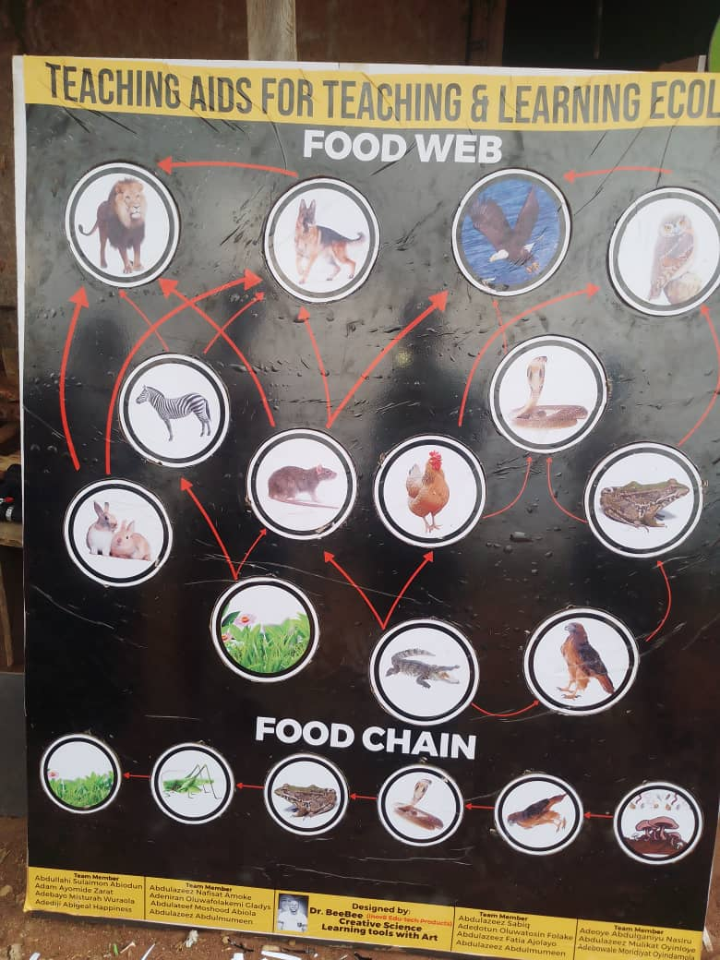
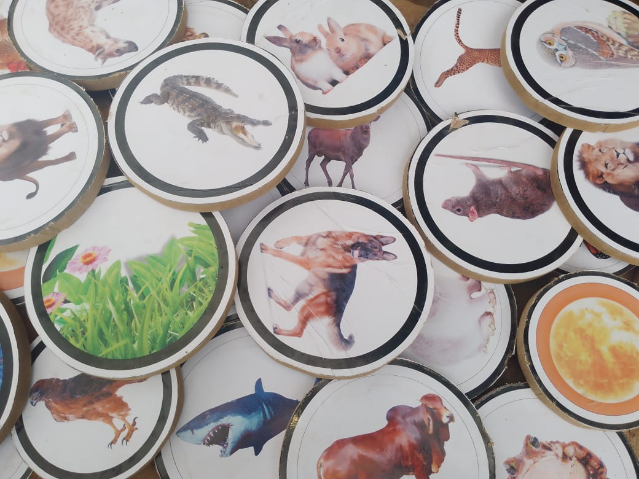
- Step 4: it removed any excess pr circular cutout from the printed image of the food webs and food chains. This step might involves trimming or cutting away excess material or shapes that weren’t part of the main design
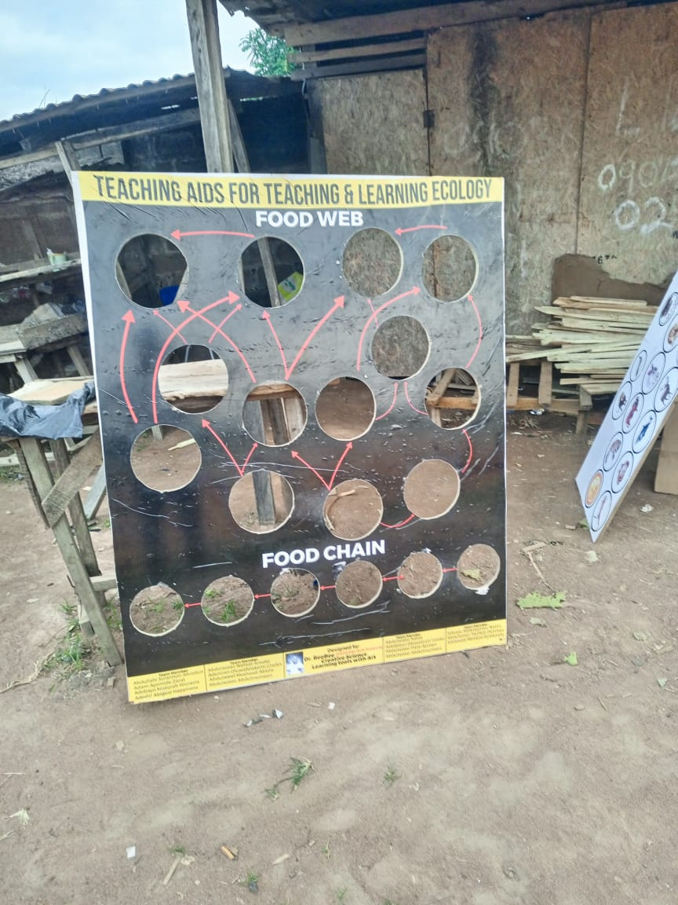

- Step 5: its reviewed display to ensure the food webs and food chain were accurate represented and clearly visible
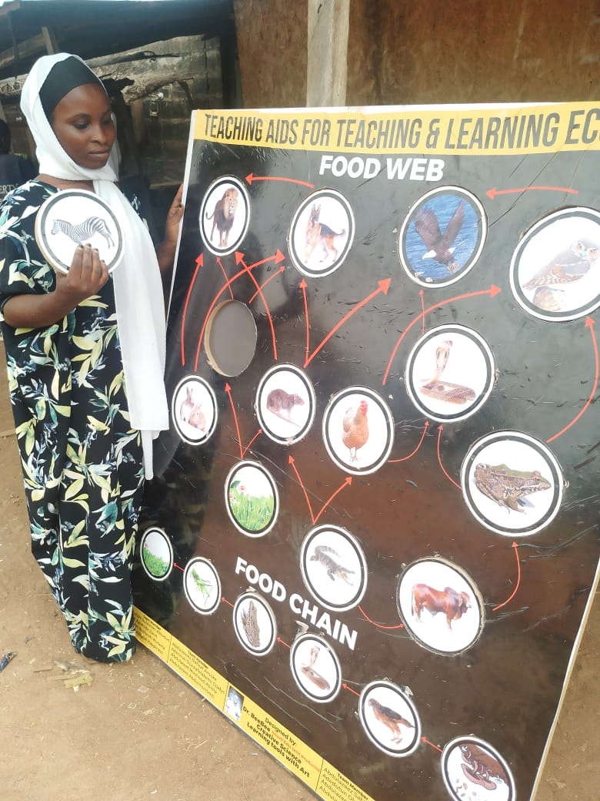
- Step 6: it added any additional features such as labels, arrows, or descriptive to enhance the display and facilitate understanding
- Step 7: its sealed or protected the display to prevent damage or ear, possible using a varnish or laminate
- Step 8: it installed or mounted the display in a suitable location, such as a classroom, office or exhibit space
- Step 9: Attach another MDF board to the back of the original MDF board to the back of the original board using screws, nails or a strong ashensive. This will provide additional support and ensure the display remain flat and secure
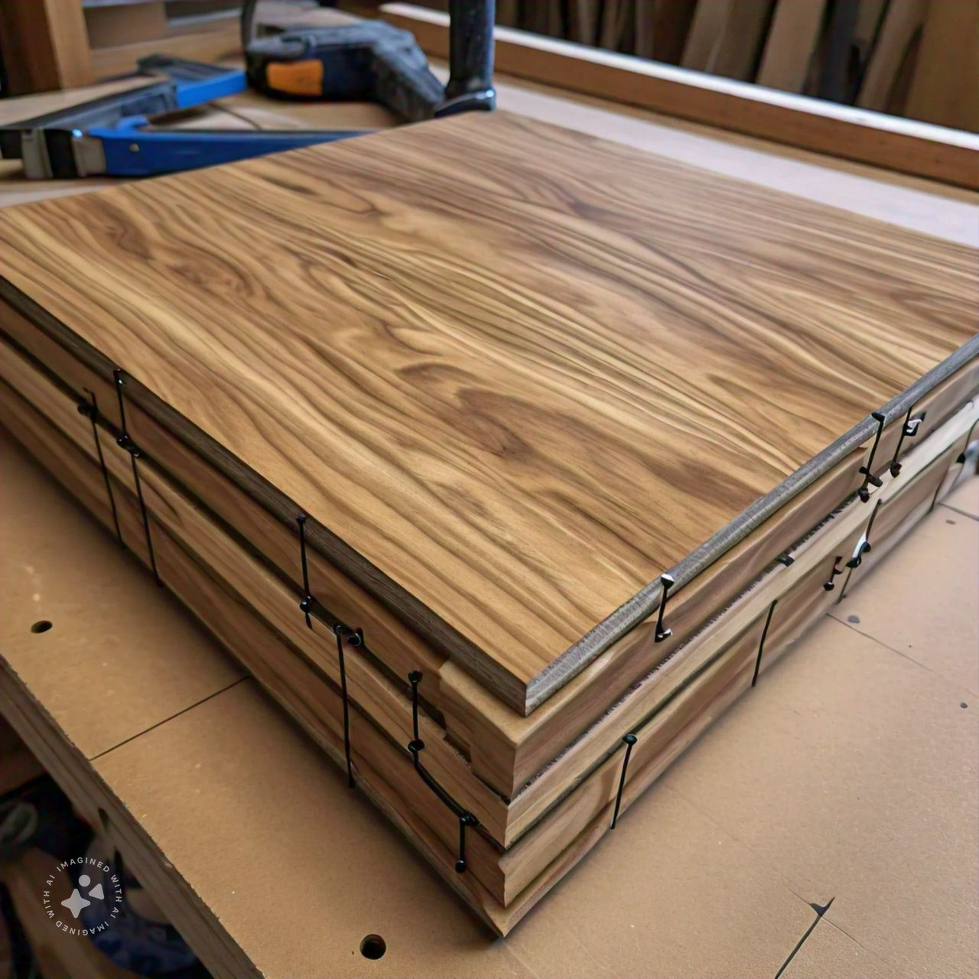
- Step 10: design and build a stand for the display, allowing it to be carried and show cased in an upright position. The stand can be made from materials like wood, metal or plastic, and can be attached to the MDF board using screw, nails or adhesive


With the stand you’ll be able to”
- Easily transport to display to different locations
- Showcase the food web and food chain display in a prominent and visible ways
- Adjust the display to different angles or heights as needed
Recommendations:
1. Wider Implementation: It is recommended that the locally made physical model be incorporated into biology curricula across various educational levels to improve understanding of amphibian species and their ecological importance.
2.Teacher Training: Teachers should receive training on how to effectively use the model in their classrooms, including strategies for integrating it into existing lesson plans and engaging students in hands-on activities.
3. Development of Supplementary Materials: Additional teaching aids, such as interactive digital content or worksheets, should be developed to complement the physical model, ensuring that different learning styles are accommodated.
4. Periodic Review and Improvement: The model should be periodically reviewed and updated based on student feedback and advances in ecological education to ensure it remains relevant and effective.
5. Community Engagement: Schools should involve local communities in the project by organizing workshops or demonstrations to raise awareness about amphibian conservation and the importance of correct identification.

Conclusion
The locally fabricated wooden model proved to be an effective educational tool for teaching the concepts of food chains and food webs in biology. Its use provided students with a more concrete and interactive understanding of these complex ecological relationships, leading to improved engagement and performance. By incorporating this hands-on model into the classroom, teachers can better address common misconceptions and enhance students' comprehension of energy flow in ecosystems. Moreover, the use of locally available materials made the model cost-effective and easy to replicate, making it suitable for schools with limited resources. The findings from this study highlight the importance of incorporating concrete instructional materials in biology education and suggest that this approach could be widely adopted to improve teaching outcomes in similar subjects.

