INFLUENCE OF INORGANIC GROWTH HORMONE APPLICATION AT TWO DIFFERENT TIMES ON THE VEGETATIVE PARTS AND FRUIT YIELD OF GARDEN EGG

BY

ABDULMUMEEN AISHAT OMOBOLANLE
KWCOED/IL/22/0006

A RESEARCH PROJECT SUBMITTED TO THE DEPARTMENT OF AGRICULTURAL SCIENCE, SCHOOL OF VOCATION, KWARA STATE COLLEGE OF EDUCATION, ILORIN IN PARTIAL FULFILLMENT OF THE REQUIREMENTS FOR THE AWARD OF THE NIGERIA CERTIFICATE IN EDUCATION. (N.C.E)

JULY, 2025
CERTIFICATION
This research project has been read and approved as meeting the requirements of the Department of Agricultural Science, Kwara State College of Education, Ilorin for the award of Nigeria Certificate in Education (NCE), in Agricultural Science.

Dr.(Mrs.) S. A. Olayiwola ….. ..…..…..…. ……..……..
Project Supervisor Signature Date

Mr. Adesanmi Ojo. ….. ..…..…..…. ……..……..
HOD Agric Signature Date

Mrs. M. D. Giwa ….. ..…..…..…. ……..……..
Project Coordinator Signature Date

DEDICATION
This research project is dedicated to Almighty Allah upon his mercy, the Lord of the heavens and the earth, the Lord of the universe, the only one who has control over the whole world; may His name be glorified.

ACKNOWLEDGEMENTS
I give thanks to Almighty Allah for sparing my life and for giving me the opportunity to complete this N.C.E programme.
My sincere appreciation goes to my project supervisor Dr. (Mrs) S.A Olayiwola whose guidance and timely advise helped me tremendously toward the successful completion of this project work.
I am greatly indebted to my beloved parent Mr & Mrs Abdulmumeen for their parental support, throughout this N.C.E programme.
I also express my gratitude to the lecturers in the department of agricultural science education, the HOD of the department Mr Ojo Adesami, Mr O.O Ogundele, Mrs I.M Obayemi, Dr T.F Olawepo, Mr J.O Aiyedun, may Allah reward you all abundantly.

ABSTRACT
A field experiment was carried out at the back of SIWES office of School of Vocational and Technical Education, Kwara State College of Education, Ilorin to determine the influence of inorganic growth hormone application at two different times on the vegetative part and fruit yield of garden egg. The research design used was Complete Randomized Design with three replicates.
The experimental materials were 20 liter plastic bucket (9 in number) polythene nylon (black, and transparent). Treatments were 15mls of morestar in 75mls of water at 4WAP, 15mls of morestar in 75mls of water at 5WAP and control.
The data collected were plant height, Numbers of leave/plant, Numbers of flowers/plant and Weight of harvested fruit/plant. The data collected from different treatment were subjected to analysis of variance (ANOVA) and means separated with Duncan multiple range tests.
The result shows that 15mls of morestar in 75mls of water at 5WAP had the higher vegetative and fruit yield than 15mls of morestar in 75mls of water at 4WAP while the control had the least.
It can be concluded that 15mls of morestar in 75mls of water at 5WAP had the higher vegetative and fruit yield than 15mls of morestar in 75mls of water at 4WAP. The application of morestar for the production of garden egg by farmers was recommended in the study area.

TABLE OF CONTENTS
TITLE PAGE I
CERTIFICATION II
DEDICATION III
ACKNOWLEDGEMENTS IV
ABSTRACT V
TABLE OF CONTENTS VI
CHAPTER ONE: INTRODUCTION
Background of Study 1
Statement of the Problem 2
Objective of the Study 3
Significance of Study 3
Scope of the Study 4
Definition of Key Terms 4
CHAPTER TWO: LITERATURE REVIEW
Origin and distribution of garden egg 5
Taxonomy of Garden Egg 6
Environmental requirements of Garden Egg 6
Cultural Requirement for Production of Garden Egg 7
Growth Period and Harvesting 8
Health Benefit of Garden Egg 8
Nutritional Composition of Garden Egg 9
Effect of Inorganic Growth Hormone on Garden Egg 9
Diagram of Garden Egg Fruit and Plant 11
CHAPTER THREE: MATERIALS AND METHODS
Experimental Site 12
Research Design 12
Experimental Material 12
Planting at nursery stage 13
Cultural Practice 14
Data Collection 14
Data Analysis 15
CHAPTER FOUR: RESULTS AND DISCUSSION
Results 16
Discussion of Result 17
CHAPTER FIVE: SUMMARY, CONCLUSION AND RECOMMENDATIONS
Summary 19
Conclusion 20
Recommendations 20
REFERENCES 21

CHAPTER ONE
INTRODUCTION
Background to the Study
The garden egg (solanum macrocarpon) also known as African egg-plant or garden aubergine is a delicate tropical perennial plant and a popular vegetable in West African cuisine, often cultivated as a tender or half-hardy annual in temperature climate. The scientific name is based on the species which are many such as Solanum melongena, Solanum macrocapon and Solanum aethiopicum. It belongs to the Family of Solanaceae which include tomatoes, potatoes and peppers. They are widely grown on the Sub-Saharan African
It grows up to 1.5m tall, the fruit is small to medium in size averaging 6-8cm in length. The stem is often spiny. The flowers are white in color with a five lobed corolla and yellow stamen. Some common cultivators have fruit that is egg shaped, the smooth skin is taut, glossy and green when young transforming to white when mature. The flesh is tender aqueous, spongy, pale yellow to white and encases many small flat seed. They also have a crunchy texture and slightly bitter flavour. They can be grown all year round either through irrigation or naturally by rain.
It is a fruit that can mostly be eaten raw as it enriches the body with minerals, Vitamins, Carbohydrates and water substances - they are very low in calories but high in fiber & potassium. thereby enhancing the proper maintenance of health and prevention of diseases. it is recommended to tackle malnutrition problem especially among women of child-bearing age and children of 5 years old (Onunka, Chinaka, and Eze, 2011). it plays a significant role in the daily diet of many Nigeria. it is used in various stew and sauces. It can be cooked with yam, plantains or rice.
According to Adekunle and Oladele (2023) garden egg has become a staple in Nigeria household for preparing traditional dishes. They are also given as gift at social event, weddings and gatherings. It is really appreciated for its nutritional value and culinary versatility most especially in Nigeria because it makes a valuable component of a healthy diet.
As noted by Akinyemi et.al (2022), it is rich in anti-oxidants which are known to reduce the risk of chronic diseases such as heart diseases and diabetes. Additionally, garden egg contains bio-active compounds that have been linked to lowering blood cholesterol and aiding digestion (Olagunju & Adetunji, 2024)
It is also reported that garden egg fruits offer gainful employment among the rural household. The root are used in Traditional medicine to treat asthma, wound, abdominal worms and stomach disorder.
Statement of Problem
Garden egg being a very popular fruit vegetable for its nutritional advantages including mineral, vitamin, bio-active compound, & anti-oxidants. Despite all these, it's cultivation, the yield and growth of fruits faces challenges such disease and lack of nutrients.
To address these challenges, this study seeks to examine the influence of inorganic growth hormone application on the vegetative part and fruit yield of garden egg. Identifying this will help farmers to produce high quantity and quality fruits, improve trader's profitability and promote healthier eating habit of the fruits.
Objective of the Study
General objective of this study is to examine the influence of inorganic growth hormone (more-star) application at two different times on the vegetative part and fruit yield of garden egg.
The specific objective includes:
- To examine the effect of in organic growth hormone on plant height
- To examine the effect of inorganic growth hormone on the number of Flowers
- To determine fruit yield of garden egg as influenced by application of growth hormone.
Significance of the Study
To help farmers to assess the importance of application of growth hormone (more-star) on performance of egg plant.
It will also help the farmer to know the rate and time of application of (more-star) on garden egg.
Scope of the Study
This study focused on the effect of growth hormone (more-star) containing cytokinin on the vegetative part and fruit yield of garden egg.
Definition of the key word /terms
Influence: the capacity to have an effect on the plant growth and development
Growth: the permanent increase in size of a plant.
Hormones: These are chemical substance that act like messenger molecules in the plant to perform specific function.
Vegetative parts are these are non reproductive part of the plant such as roots, Stem, leaves, shoot and buds.
Fruit yield: refers to the amount of fruit harvested from a specific plant within a season, or number of fruits produced within a giving or growing season.
Garden egg is an edible egg shaped small fruit

CHAPTER TWO
LITERATURE REVIEW
Origin and distribution of garden egg
Zeven and Zhukorshky (2012) reported, garden egg to have originated from India but spread east ward and by the 5th century B.C. it was first cultivated in China which became a secondary centre of origination. Thus, it has been known for the last 1500 years in china, Arabic and Persians were responsible for the subsequent movement to Africa and Spain. It is now widely cultivated for its fruits in the tropical, subtropical and warm temperature zone especially in Southern Europe and the Southern United State.
Vavilov (2022) was of the opinion that its centre of origin was in the indo-Burma. A centre of diversity which is believed to be in the region of Bangladesh and Myanmar (former India-Burma border). Evidence to this was given by Isshiki et. al. (2020) based on the enzyme and morphological variation noticed in large germplasm collection from India. It was presumably spread from Spain to the rest of the Europe (Ratnala, 2014).
Nowadays, egg plants are cultivated worldwide but the two main production regions are Asia and the Mediterranean (Daunay, Chdna, 2014) it was widely grown and found ina local market in Africa, southeast Asia, Europe, Brazil, the Caribbean and in selected region of the United States.

Taxonomy of Garden Egg
Kingdom: Plantae

Phylum: Tracheophyta

Class: Magnoliopsida

Order: Solanales

Family: Solanaceae

Genus: solanum

Species: Macrocarpon

Environmental requirements of Garden Egg
The garden egg grows and develops in warm season with relatively high temperature. It requires optimum day temperature of 25⁰C -30⁰C and optimum night temperature of 20⁰C-27⁰C (Norman, 2011, Obeng-Oferi, et. al., 2017) soil with high temperature are harmful to the root system and can be minimized by mulching. The garden egg can grow both in the rainy and dry season but too much rainfall will check vegetative growth and flower formation (Rice et. al, 2011).
Garden egg also requires a well-drained soil with good water holding capacity. The root system is sensitive to excess water and deep cultivation prior to planting is required (Rice et.al, 2015). This soil should be fertile with organic matter and PH ranging from 5.5-6.5 is suitable for good production.
The early cultivators grow well in sandy-loam soil while local cultivators do well in clay-loam soil (Obeng-Oferi, et.al, 2017). Norman, (2022) argued that the crop should be cultivated on soils with high organic matter content. Water logging is also likely to cause leaf drop in garden egg and they are drought tolerant and requires at least 6 hour of direct sunlight.
Cultural Requirement for Production of Garden Egg
Clearing land of weeds propagated from seeds often nursery-raised before transplanting. Transplant healthy seedlings often 4-6weeks when they are about 10-15cm tall. Spacing of about 60 cm apart in rows is required. Regular watering is essential especially during dry season, avoid over wetting. Consistent moisture is the best. Mulching helps in the conservation of soil moisture of garden egg farm plantation. Proper weeding must be carry out in order to allow good and proper development of garden egg.
Also mismanagement of irrigation or injudicious application of excess water on garden egg has some adverse effect on it. Hagan et. al (2018) asserted that excessive irrigation delay maturity, harvesting, encourage vine growth and reduce a soluble solid content of tomatoes while insufficient moisture decrease yield and crop quality.
Monitoring of pest and disease is important, according to Horna and Gruere (2016), a number of pest and diseases attack this vegetable crop on the filed such as mites, stem borers, fruit borers and flower borers which are the main pest that attack garden egg which cause damage, reduces yield and affect the quantity and quality of the produce.
Growth Period and Harvesting
The growth period of garden egg varies depending on the varieties. Germination of garden egg take place between 7-14days of seed sprout and seedling to emerge. Young plant starts to develop set of leaves within one-two weeks before flowering and fruiting between 90-120days from sowing seed to harvesting of matured fruits (Adeojo, 2022).
Harvesting of garden egg should be done at least between 60-90days after transplanting based on the desired color which varies depending on the variety, the size and also the texture should be considered. Use of scissors and sharp knife to avoid damaging of the fruit. Harvesting must be done in the morning when the plant are typically at their highest water content.
Health Benefit of Garden Egg
Garden egg have some health benefit which are;
African eggplant extract is a potential source of natural antioxidant that help to control disorder caused by oxidative stress. The extract can be used in the pharmaceutical and food industry. Garden egg leaves contain an anti-inflammatory property making them one of the suitable vegetable to reduce swelling and preventing cancer causing inflammation.
They help with digestion and blood pressure control due to their fibre and potassium content. Garden egg contains vitamins A, B₆ and C. these are essential for improving the immune system, vision and brain development and function. Vitamin B₆ helps in the production of serotonin, a neurotransmitter that helps you sleep better and aid bone health. 100g of garden egg predictably contains about 9g of calcium and 114mg of phosphorus. It provides the body with potassium, iron and magnesium (Adeojo, 2022).
Nutritional Composition of Garden Egg
The nutritional content of garden egg is comparable to that of tomato, but it has a lower content of Vitamin C. nutritional value of 100g of garden egg. Contains water 90.6g, energy 32kcal, protein 1.5g, fat 0.1g, carbohydrate 7.2g, fiber 2.0g, calcium 28g, phosphorus 47mg, iron 1.5mg, vitamin A 70mg, thiamin 0.07mg, riboflavin 0.06mg, niacin 0.8mg, ascorbic acid 8mg (Grubben and Denton, 2014).
Effect of Inorganic Growth Hormone on Garden Egg
The cultivation of vegetable crops often involves intricate manipulation of growth and development process to achieve desired outcomes in terms of yield, quality and appearance. One powerful tools in the hand of farmer is the strategic application of growth hormone or plant hormone. The plant hormones are extremely important in the integration of development activities (Suman et.al, 2017). Growth hormone plays a pivotal role in shaping the growth patterns, physiological response and overall performance of crops. Hormone allow the producer to design the growth of crop having effect on root development, flowering, fruit set and post harvesting characteristics. Plant hormone affects the physiological development (growth differentiation and stomata development) (Davies, 2020).
Cytokinin plays a very crucial role on the cell cycle and affects the plant growth and development (Honig, et.al, 2018). Cytokine have a significant impact on regulation of plant growth, stabilization of photosynthetic ability during stress and exogenous application and modulation of cytokinin levels have a positive effect on drought tolerance (Rivero et.al, 2017).
Research findings shows that cytokinin can alleviate the damage to plant caused by a variety of abiotic stress (Mi et.al, 2017, Prerostiva, et.al, 2018). Unlike other hormones cytokinin are found in both plants and animals and they are considered to be master regulators of plant growth and development as well as being involved in the regulation of many important physiological and metabolic process in crop plant (Wu, et.al, 2020).

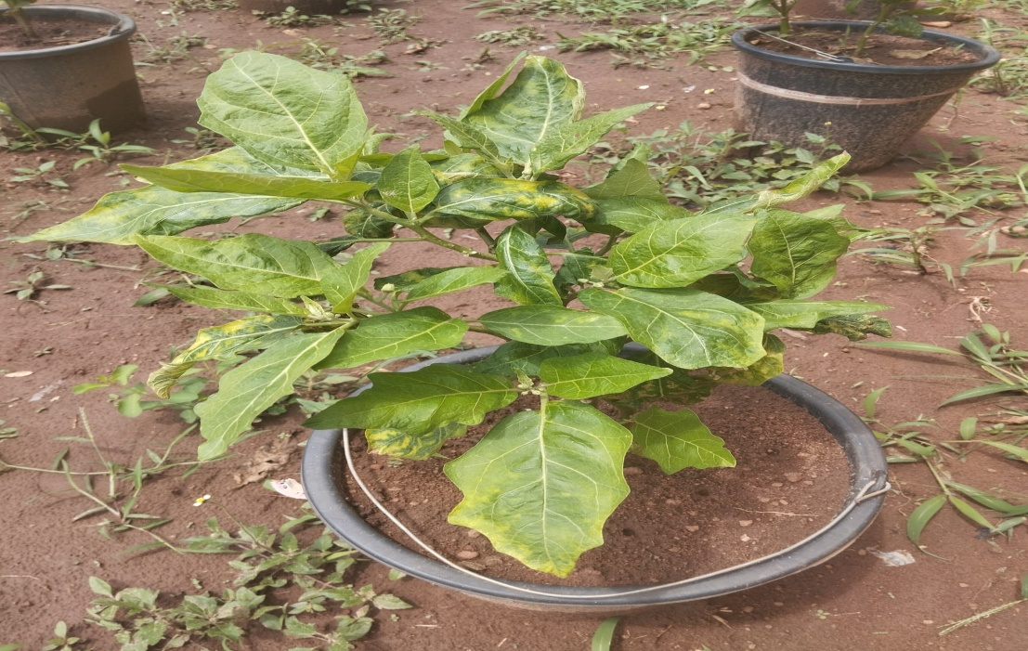

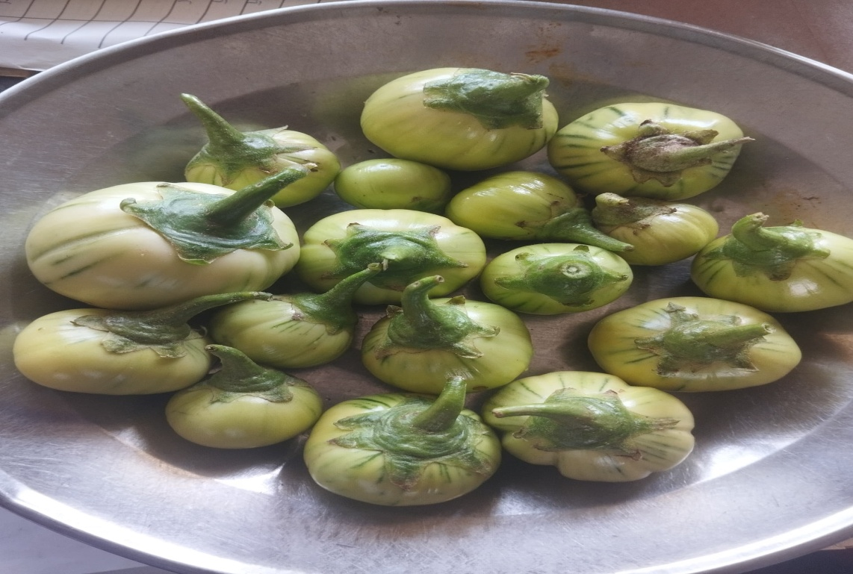
A TYPICAL GARDEN EGG PLANT

A PICTURE OF GARDEN EGG FRUITS
SOURCE: A REAL OBJECT FROM THE FARM SEPTEMBER, 15TH 2025

CHAPTER THREE
MATERIALS AND METHODS
Experimental Site
The experiment was carried out at the back of SIWES director office of School of Vocational and Technical Education, Kwara State college of Education, Ilorin, Kwara State to determine the influence of inorganic growth hormone (more-star) application at two different time on the vegetative part and fruit yield of garden egg.
Research Design
The research design used was complete randomized design with three replicate.
Experimental Material
Garden egg seed used for the experimental was obtained from a local farmer at Lafiaji, Kwara state. The hormone used which is more-star contained cytokinin was purchased from at G.Y. Bello agrochemical shop along Muritala Mohammed road, Ilorin. Others experimental materials were experimental plastic (20 litres in size) pot, Tape rule, sensitive scale, handheld spraying can (14 litres)in size, organic mulching material (dry grasses), black polythene nylon, a micronutrient liquid growth hormone(more-star).
Nine plastic buckets ( 20 litres) in size that had been previously drilled were used. The buckets were filled with sieved soil sample of the experimental size using a 2mm diameter rubber sieve.
Planting at nursery stage
Ten seeds were sown by drilling method in each experimental pot and covered the T₂ with organic mulching dry grasses and T₃ were covered with black polythene sheath to know the effects of mulching on the plant and prevent weed infestation. The experiment pots were put under the tree to provide shade for the plant. To determine the rate of germination and emergence of the seed.
The treatment used were applied as follows
- T₁ - control
- T₂ - 15ml of more-star in the first week
- T₃ - 15ml of more-star in the second week
ii) Field experiment
T₁R₁ – control at rep 1
T₁R₂ - control at rep 2
T₁R₃ - control at rep 3
T₂R₁ – 15mls of more-star at rep 1
T₂R₂ - 15mls of more-star at rep 2
T₂R₃ - 15mls of more-star at rep 3
T₃R₁ – 15mls of more-star at rep 1
T₃R₂ - 15mls of more-star at rep 2
T3R₃ - 15mls of more-star at rep 3
Cultural Practice
Hand hoeing was done to control the weed within the pot and the surrounding. Watering was done regularly using watering can to increase the soil moisture.
Control of pest and disease were done using Cypertex 10EC insecticide and glyphosate herbicide was used to prevent the weed population as explained by the supervisor.
Data Collection
Data collection commence at two weeks after planting. The following data were collected
Plant height: it was determined by measuring the height of plant from soil marked to the terminal region using a wooden ruler.
Number of leaves per plant: this was done by physical counting of numbers of leaves and recorded.
Number of flowers: it was carried out by counting the numbers of flowers per plant and recorded.
Numbers of harvested fruits: This was done at point of harvesting by counting the number of freshly harvested fruits, recorded and weight of harvested fruits were determined by weighing on sensitive scale and recorded in (gm).
Data Analysis
The data collected were subjected to (ANOVA) Analysis of Variance and means separated by Ducan multiple range test.

CHAPTER FOUR
RESULTS AND DISCUSSION
This chapter deals write the presentation of results in tables and this was followed by the discussion of results
RESULTS
Table 1: influence of inorganic growth hormone application at two different times on plant height (cm) of garden egg.
 | 4WAP | 6WAP | 8WAP | 10WAP | 12WAP
T₁ | 7.2b | 15.2b | 17.8c | 20.7c | 22.4c
T₂ | 5.8a | 15.5a | 18.4b | 24.3b | 25.0b
T₃ | 5.6a | 17.3a | 21.5a | 24.3a | 28.8a
Mean with the same letters are not significantly different.

Table 2: influence of inorganic growth hormone application at two different times on number leaves of garden egg.
 | 4WAP | 6WAP | 8WAP | 10WAP | 12WAP
T₁ | 7.2a | 13.0b | 15.8b | 17.6b | 19.0c
T₂ | 7.4a | 14.0b | 16.0b | 18.0b | 20.0b
T₃ | 6.2a | 16.0a | 18.0a | 20.0a | 22.4a
Mean with the same better presents significant different

Table 3: Influence of inorganic growth hormone application at two different times on the numbers of flowers/plant and fruits/plant(g) of garden egg.
 | Number of Flowers/plant | Weight of Fruits/plant
T₁ | 53c | 30c
T₂ | 60b | 38b
T₃ | 69a | 42a
Mean with the same better presents significant different

Table 1 above shows the influence of inorganic growth hormone application at two different times on plant height (cm) of garden egg. 15mls of more-star in 75mls of water at 5WAP had the tallest plant height throughout the experiment and the control consistently had the shortest plant height.
Table 2 above shows the influence of inorganic growth hormone application at two different times on number of leaves of garden egg. 15mls of more-star in 75mls of water at 5WAP consistently had the highest number of leaves per plant throughout the experiment and the control consistently had the shortest plant similar to what was obtained in plant height.
Table 3 above indicate influence of inorganic growth hormone application at two different times on the numbers of flowers/plant and fruits/plant of garden egg. As observed in the vegetative growth, the effect was also significant at the experiment. 15mls of more-star in 75mls of water at 5WAP had the highest number of flowers (69) and weight of fruit per plant which was significantly higher than 15mls of more-star in 75mls of water at 4WAP (60)and the control had the least number of flowers (53)and weight of fruit per plant (30g).
Discussion of result
The result shows that treatment with 15mls of more-star in 75mls of water at 5WAP had the tallest plant and number of leaves/plant while the non fertilized garden egg had the shortest plant and least number of leaves/plant.
The result is expected as the manure had organic N for vegetative growth. The result is in line with the works of Akanbi et al., (2016) and collaborate the work of Kolawole (2018)
Similarly 15mls of more-star in 75mls of water at 5WAP had the more number of flowers/plant and number of fruits/plant than the non fertilized plant. The result is in line with the works of Eze et al., (2014) and collaborate the work of Adeyemi, (2020)

CHAPTER FIVE
SUMMARY, CONCLUSION AND RECOMMENDATIONS
Summary
A field experiment was carried out at the back of SIWES office of School of Vocational and Technical Education, Kwara State College of Education, Ilorin to determine the influence of inorganic growth hormone application at two different times on the vegetative part and fruit yield of garden egg.
The research design used was Complete Randomized Design with three replicates. The experimental materials were 20 litres plastic bucket (9 in number) polythene nylon (black) and dry grass. Nine plastic buckets (20 litres) in size that had been previously drilled were used.
The pots were arranged into three (3) rows i:e 3 buckets per row and each bucket labeled T₁-T₃ and in randomized design. Each of the treatment bucket were covered with black polythene, and dry grasses as appropriate with T₁- control where the bucket was not covered at all, T₂- buckets covered with dry grasses, and T₃ were represented by buckets covered with black polythene materials. These were provided to serve on a synthetic mulching material for germination, and emergence of seedlings.
Treatments were 15mls of more-star in 75mls of water at 4WAP, 15mls of more-star in 75mls of water at 5WAP and control. Cultural practices that were carried out involved regular weeding both within the pots and around the experimental area. Application of insecticide using Cypertex 10EC was also carried out.
The data collected were plant height, Numbers of leaves/plant, Numbers of flowers/plant and Weight of fruits/plant. The data collected from different treatment were subjected to analysis of variance (ANOVA) and means separated with Duncan multiple range tests.
The result shows that 15mls of more-star in 75mls of water at 5WAP had the higher vegetative and fruit yield than 15mls of more-star in 75mls of water at 4WAP while the control had the least.
Conclusion
It can be concluded that 15mls of more-star in 75mls of water at 5WAP had the higher vegetative and fruit yield than 15mls of more-star in 75mls of water at 4WAP.
Recommendations
The researcher would like to make the following recommendations.
- The application of more-star for the production of garden egg by farmers
- The application of 15mls of more-star in 75mls of water at 5WAP for the production of garden egg by farmers
- Further studies should be done on the effect of 15mls of more-star in 75mls of water at 5WAP on fruit qualities of garden egg.
- Further studies should be done on the 15mls of more-star in 75mls of water at 5WAP on other crop

REFERENCES

Anderson, C. R. (2019). Garden egg – Solanum melongena-perennial. Cooperative Extension Service. University of Arkansas. <http://www.uaex.edu/vegfacs/gardenegg.html>
Arunachalam, V. (2011). Genetic distances in plant breeding. Indian Journal of Genetics 41: 226-236
Ayad, W. G., Hodgkin, T., Jaradat, A. and Rao, V. R. (2022). Molecular genetic techniques for plant genetic resources. Report of an IPGRI workshop.
Chadha, M. L. and Saimbhi, M. S. (2017). Varietal variation in flower types in brinjal (Solanum melongena L.). Indian Journal of Horticulture 34: 426-429.
Chaplin, L. T. (2024). “Grow melt-in-your-mouth garden egg”. Organic Gardening. Emmaus, Pennsylvania: Rodale Press. Volume 41(7), September/October.
Daunay, M.C and Chadha, M.L. (2020). solanum melongena L. (Internet record) from PROTA4U Grubben G.J.H & Denton, O.A (Editors) PROTA plant resources of Tropical Africa wageningen Netherland.
Doganlar, S. Frary A, Daunnay M.E. Lester A. (2012). Comparative genetic Linkage map of Eggplant and Its Implication.
Doganlars, S. A., Frary, M. C., Daunay. Lester, R. N. and Tansley, S. D. (2022). Conservation of gene function in the Solanum as revealed by comparative mapping of domestication traits in garden egg. Genetics 161:1713-1726.
Doijiode, S.D. (2019). ‘Seed storage of horticultural crops.’ Haworth Press: ISBN 1560229012
Frary, A., Doganlar, S. and Daunay, M. C. (2017). Garden egg. In C. Kole (ed.) Genome mapping and molecular breeding in plants. Volume 5: 287-313. Springer Verlag Berlin Heidelberg.
Furini, A. and Wunder, J. (2024). Analysis of garden egg (Solanum melongena) related germplasm; morphological and AFLP data contribute to phylogenetic interpretations and germplasm utilization. Theoretical and Applied Genetics 108: 197-208.
Honig, MPlihalova L. Husic Kova A. Nisler J, Polezal k. (2018). Role of Cytokinin in senescence, Antoxidant defence and phyosynthesis.
Krishnamurthi, S. and Subramanium, D. (2014). Some investigations on the types of flowers in brinjal (Solanum melongena) based on style length and their fruit set under natural conditions and in response to 2, 4-D. Indian Journal of Horticulture 11: 63-67
Mabberley, D. J. (2018). The Mabberley Plant Book; a portable dictionary of plants. Their classification and uses. Cambridge University Press, Cambridge, UK.
McGregor, S. E. (2016). Insect pollination of cultivated crop plants. Agriculture Handbook No. 496, Agricultural Research Service, USDA, Washington, http//gears.tucson.ars.ag/book/index.html.
Obeng-Ofori, D. Danguah, E.Y & Ofosu Anim, L. (2017). Vegetable and spice crop production in west Africa. City Publishers
Ornorman, J.C. (2022). Tropical Vegetable crops. Arthur H. Stockwell Ltd.
Osei, M. K., Banfull, B., Osei, C. K. and Oluoch, M. O. (2021). Characterization of African garden egg for morphological characteristics. Journal of Agricultural Science and Technology 4(3), 33-37.
Owusu-Ansah F., Afreh-Nuamah K., Obeng-Ofori, D. and Ofosu-Budu, K. G. (2021). Managing Infestation Levels of Major Insect Pests of Garden Eggs (Solanum integrifolium L.) with aqueous nee, seed extracts. Journal of the Ghana Science Association 70-84.
Passam, H. C. and Bolmatis, A. (2017). The influence of style length on the fruit set, fruit size and seed content of aubergines cultivated under high ambient temperature. Tropical Science 37: 221-227.
Patel, K. K., Sarnaik, D. A., Asati, B. S. and Tirkey, T. (2021). Studies on variability, heritability and genetic advance in Brinjal (Solanum melongena L.) Agricultural Science Digest 24: 256-259.
Rahim, M. A., Mia, A. A., Mahmud, F., Zeba, N. and Afrin, K. (2022). Genetic variability, character association and genetic divergence in mungbean (Vigna radiate L. Wilczek). Plant.
Rao, K. N. (2024). Plant genetic resources: Advancing conservation and use through biotechnology. African Journal of Biotechnology 3(2): 136-145. http://www.bioline.org.br.
Ratnala, T. N. (2014). Brinjal. Sigapore inforpedia. https://resources.nlb.gov.sg/infopedia/article/sip-171-2004-12-15html.
Rice, R.P, Rice, L.W and Tindall H.D. (2023). fruits and Vegatable production in Africa. The Macmillian Press Limited London and Basingstoke pp227-230.
Rivero R. M. Kojima, M. Gepstein A. Sakakibara H., Mittler, R. Gepstein S. et al. (2017). characterization and express on Analysis of Cytokinin biosysthesis gene in Fragaria Vesca.
Shukla, V. and Naik, L. B. (2023). Agro-techniques of solanaceous vegetables, In: Advances in Horticulture, Volume 5, Vegetable Crops, Part 1, K. L. Chadha and G. Kalloo (eds.). Malhotra Publication House, New Delhi. Pp. 365.
Shukla, V. and Naik, L. B. (2023). Agro-techniques of solanaceous vegetables, In: Advances in Horticulture, Volume 5, Vegetable Crops, Part 1, K. L. Chadha and G. Kalloo (eds.). Malhotra Publication House, New Delhi. Pp. 365.
Thomas, B. and B. Vince-pruce, (2017). Photoperiodic in Plants, 2Ed, Academic Press, San Diego., pp: 4.
Tindall, H. D. (2018). Fruit and vegetables in West Africa. FAO Plant Production and Protection Series, Rome.
Tsao and Lo. (2016). ‘In Y. Hui: Handbook of food science, technology, and engineering, Boca Raton. ‘Taylor and Francis, ISBN 1574445510
Valilov, N. (2022). the biological component of the eggplant. Fifth international congress of genetics. Newyork pp 342-367
Wiki (2023). eggplant. From Wikipedia the free encyclopedia. Httpp://wikipedia.org/wiki/eggplant
Zeren, A. C and Zhukuosky, P.M. (2012). Dictionary of cultivated plants and their centre of diversity excluding ornamental forest trees and lower plants.

