EFFECTS OF BASAL APPLICATION OF MICRO NUTRIENTS AT DIFFERENT TIMES ON FRUIT YIELD OF GARDEN EGG (Solanum melongena)

BY

ABDULRAHMAN ZAYNAB KEHINDE
MATRIC NO: KWCOED/IL/22/0011

A RESEARCH PROJECT SUBMITTED TO THE DEPARTMENT OF AGRICULTURAL SCIENCE, KWARA STATE COLLEGE OF EDUCATION, ILORIN.

IN PARTIAL FULFILLMENT OF THE REQUIREMENT FOR THE AWARD OF NIGERIA CERTIFICATE IN EDUCATION (N.C.E) AGRICULTURAL SCIENCE.

July, 2025.
CERTIFICATION
This research project has been read and approved as meeting the requirements of the Department of Agricultural Science, Kwara State College of Education, Ilorin for the award of Nigeria Certificate in Education (NCE), in Agricultural Science.

Dr.(Mrs.) S. A. Olayiwola ..…..…..…. .……..
Project Supervisor Signature Date

Mr. Adesanmi Ojo. …..…..….. ………
HOD Agric Signature Date

Mrs. M. D. Giwa ....………. ...……
Project Coordinator Signature Date

DEDICATION
This research project is dedicated to Almighty Allah upon his mercy, the Lord of the heavens and the earth, the Lord of the universe, the only one who has control over the whole world; may His name be glorified.

ACKNOWLEDGEMENTS
I appreciate God the Almighty for his faithfulness and his grace in preserving my soul and strengthened me to see through the successful completion of this project and my N.C.E programme.
My appreciation goes to my project supervisor in the person of Dr. (Mrs.) S. A. Olayiwola for her scholarly support, understanding and contribution towards the successful completion of this project work.
My sincere appreciation goes to other lecturers in the Department of Agricultural Science viz, Mr. Ojo Adesami, the HOD of the department Mr. Ogundele O.O, Mrs. Obayemi I.M, Dr. T.F Olawepo, ,Mr. J.O Aiyedun.
I am indebted to my parents Mr. and Mrs. Abulrahman for their parental support from inception till moment.Their encouragement and prayers over my life has contributed positive to my life and career.
My worm gratitude goes to my sister Miss AbdulRahman Aisha for been there for me whenever her attention needed, I cannot leave out other family members in person of Mr. AbdulRahman AbdulRahman I also thank my Mrs. AbdulRahman Aisha.

ABSTRACT
A field experiment was carried out at the back of SIWES office of School of Vocational and Technical Education, Kwara State College of Education, Ilorin to determine the effect of two different rates of micro nutrients (C-maxi force) on vegetative growth and yield of Garden egg.
The research design used was Complete Randomized Design with three replicates. The experimental materials were 20 litres plastic bucket (9 in number) polythene nylon (black, and transparent). Plastic bucket were filled with soil and moistened before covering with Nylon .The Nylon were perforated to allow seeds to be dropped and give way for emergence of seedlings after which as like adoption ofone1 seed per hole was a method of planting used, while 10 holes were drilled per pot these give a total number of 10 seeds per pot. Seeds were lightly watered immediately after planting. Watering continued at 2days interval until the whole seeds were observed to have germinated. Treatments were applied at 60 days after planting by adding 5mls of C-maxi force in 20 litres of water (T₂) and Treatment three was adding using 10mls of C-maxi force in 20 litres of water (T₃).
The data collected were plant height, Numbers of leave/plant, Numbers of flowers/plant and Weight of fruits/plant. The data collected from different treatment were subjected to analysis of variance (ANOVA) and means separated with Duncan multiple range tests.
The result shows that 10mls of C-maxi force in 20litres of water had the higher vegetative and fruit yield than 10mls of C-maxi force in 20 litres of water while the control had the least.
It can be concluded that 10mls of C-maxi force in 20 litres of water had the higher vegetative and fruit yield than 5mls of C-maxi force in 20 litres of water. The application of 10mls of C-maxi force for the production of garden egg by farmers was recommended.

TABLE OF CONTENTS
TITLE PAGE I
CERTIFICATION II
DEDICATION III
ACKNOWLEDGEMENTS IV
ABSTRACT VI
TABLE OF CONTENTS VII
CHAPTER ONE: INTRODUCTION
Background of Study 1
Statement of the Problem 2
Objective of the Study 3
Significance of Study 3
Scope of the Study 3
Definition of Key Terms 4
CHAPTER TWO: LITERATURE REVIEW
Variety of garden egg 5
The Benefits of Garden Eggs . 8
Medicinal Uses 9
Cultivation of garden egg 9
Effect of Nutrient application on plant growth and yield
parameters and yield 10
Factors affecting garden egg production 13
CHAPTER THREE: RESEARCH METHOD
Experimental Site 16
Research design 16
Experimental Materials 16
Planting 17
Pot experiment 17
Cultural Practices 17
Data Analysis 18
CHAPTER FOUR: RESULTS AND DISCUSSION
Results 19
Discussion of Result 21
CHAPTER FIVE: SUMMARY, CONCLUSION AND RECOMMENDATIONS
Summary 22
Conclusion 24
Recommendations 24
REFERENCES 25

CHAPTER ONE
INTRODUCTION
Background to the study
Garden egg (Solanum melongena) is one of the major vegetables grown in West Africa, the crop is known by several names like aubergine and egg plant in Europe and United States, "bringers" in South East Asia and it is only known as garden eggs in West Africa (Obeng-Ofori et al., 2017). The crop is grown for either the immature fruits or leaves depending on the locality. The immature fruits are either eaten raw or cooked (Grubben and Denton, 2014).
The crop is cultivated in tropical Africa, Asia and America and throughout the tropical and subtropical areas (Tindall, 2022). Garden egg fruits are known for being low in calories and having a mineral composition beneficial for human health. They are also a rich source of potassium (K⁺), magnesium (Mg⁺), calcium (Ca²⁺) and iron (Fe³⁺). Garden egg fruits are known for being low in calories and having a mineral composition beneficial for human health. The fruit can be eaten raw or served as a baked, grilled, fried or boiled vegetable and can be used in stews. The area devoted to the cultivation of the crop globally is about two million hectares (FAO, 2017).
With the growing consumption of garden eggs, there is a need to ensure high quality fruits with minimal or no sacrifice of quality and at the same time leaving the soil un-degraded chemically, physically and biologically. Foliar fertilization is gaining more importance in recent years due to availability of soluble fertilizers and is of great significance in rain fed areas and under changing climatic conditions. Many research reports indicated positive effect in enhancing crop yield and quality of oilseed/pulse crops. Foliar application of nutrients constitutes one of the important milestones in the progress of agricultural production. Fertilizer applied to the crop at the time of sowing is not fully available to the plants as the crop approaches maturity so supplemental foliar application is one of the techniques to increase yield of the crop. It has been established in various research studies that plant leaves and other above- ground parts are capable of absorbing chemicals and nutrients. Absorption of nutrients by plants is not a function limited to the root system.
Statement of problem
With the growing consumption of garden eggs, there is a need to ensure high quality fruits with minimal or no sacrifice of quality and at the same time leaving the soil un-degraded chemically, physically and biologically. That was why Foliar application and side placement of N.P.K 15:15:15 fertilizer were applied at different rates to garden egg plants and the comparative effects were taken into consideration to help us know the which treatment is best suited for production of garden egg for maximum yield and soil conservation.
This work was therefore designed to evaluate the effects of growth hormone on the growth and fruit yield of garden egg.
Objectives of the study
The general objective of this study is to determine the effects of basal application of micro nutrients at different times on fruit yield of Garden egg.
The specific objectives are to determine the effect of basal application of micro nutrients at different times on
i Plant height of garden egg
ii Number of leaves per plant of garden egg
iii. Number of flowers per plant of garden egg
iv Weight of fruits per plant of garden egg
Significance of the study
The significances of this study as follow:
- It would enlighten the farmer on the availability and the use of micro nutrient on garden egg production.
- It would contribute to the knowledge on the importance and effect of micro nutrient in crop production.
Scope of the study
This study was limited to one variety of garden egg in one ecological zone that is southern guinea savannah in Ilorin. Also only one type of micro nutrient was used.

Definition of key terms
Garden egg: Fruit vegetable eaten by man
Micro nutrient: C maxi force manufactured organic substance
Fruit yield: The harvest from garden egg that is edible to man
Growth: Permanent increase in size as a result in increase in number of cells
Effect: Influence on growth and yield.

CHAPTER TWO
LITERATURE REVIEW
Variety of garden egg
Solanum melongena: This is one of the most commonly cited botanical names for garden egg, particularly for the common garden egg or aubergine.
Solanum aethiopicum: This species is also known as the scarlet garden egg or Ethiopian garden egg and is commonly referred to as garden egg in some regions, especially in West Africa.
Solanum macrocarpon: Known as the African garden egg or Gboma, this species is also referred to as garden egg in some contexts.
Solanum gilo: Some sources suggest this as a possible botanical name for garden egg, although there's debate about whether it's a distinct species or part of the Solanum aethiopicum complex.
It's worth noting that the taxonomy of African garden eggs is complex, and different sources may group these plants differently. However, Solanum melongena and Solanum aethiopicum are two of the most widely recognized species referred to as garden egg.
Origin of garden egg
Garden egg, scientifically known as Solanum melongena, is a vegetable crop native to Sub-Saharan Africa and is widely cultivated for its edible fruits and leaves. It is valued for its nutritional content and culinary versatility. Garden egg is known by various names, including African garden egg, Ethiopian garden egg, or scarlet garden egg.
In Nigeria, specifically, garden egg also known as “ikan or yalo in Yoruba and Hausa respectively” big sized green fruit with very deep and sweet endocarp is grown commercially while in the savannah zone of Nigeria; the yellow, white and thick green skinned varieties are grown on large scale.
Garden egg originated in tropical Africa. It has been cultivated in Sub-Saharan Africa for centuries. It was introduced to England in the late 1500s, where it became popular before the introduction of purple garden eggs from Asia, according to Specialty Produce (Roberts, 2021).

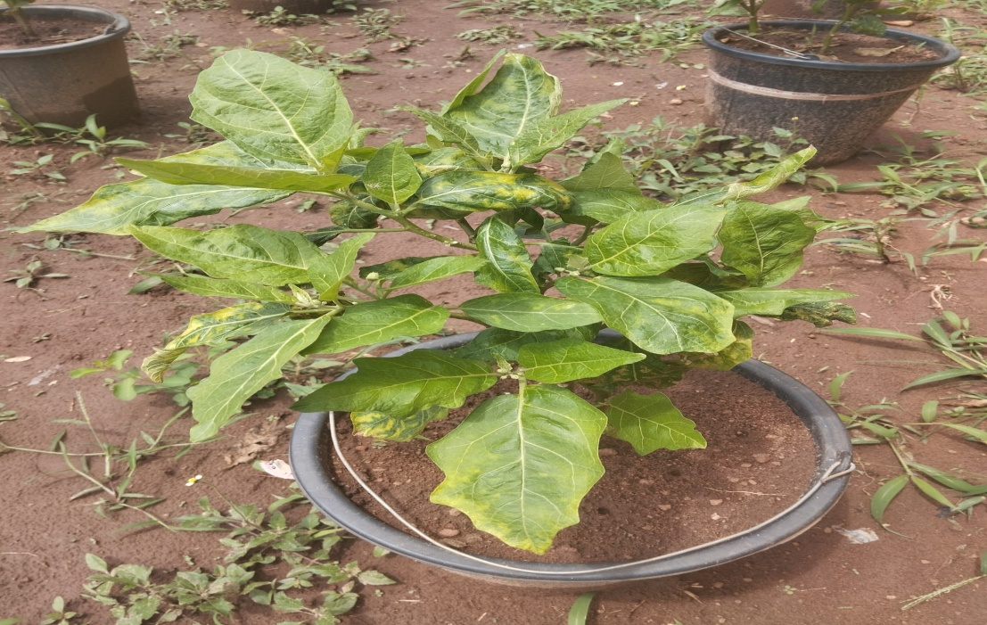
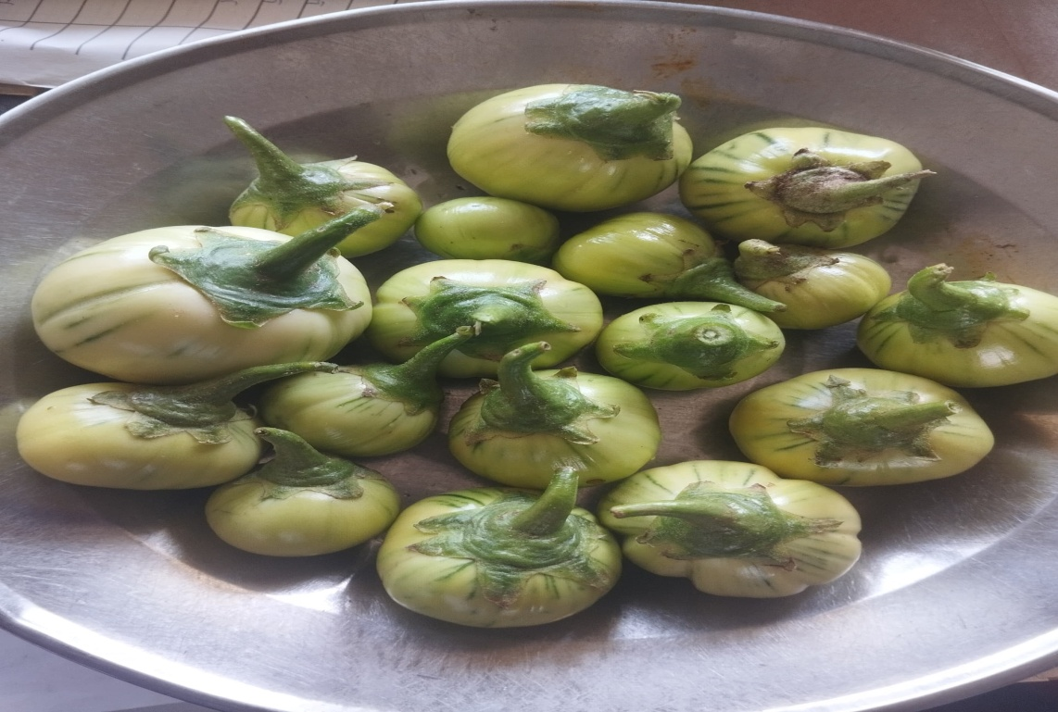
A PICTURE OF GARDEN EGG FRUITS

A TYPICAL GARDEN EGG PLANT
The Benefits of Garden Eggs .
Garden eggs, scientifically known as Solanum melongena and Solanum aethiopicum, are a popular vegetable in many parts of the world, particularly in Africa. They are known for their nutritional and medicinal properties, with a range of potential health benefits. This review will explore the literature surrounding garden eggs, covering their nutritional composition, medicinal uses, and cultivation practices.
Nutritional Composition:
Garden eggs are a good source of various vitamins and minerals, including vitamins A, B1, B2, B6, C, and E, as well as minerals like potassium, magnesium, calcium, and iron. They are also rich in dietary fiber, which aids in digestion and promotes overall gut health.
Some studies have indicated that garden eggs contain phenolic compounds like caffeic acid and chlorogenic acid, which contribute to their antioxidant capacity.
Garden eggs also contain saponins, tannins, and other phytochemicals with potential health benefits. Different species and varieties of garden eggs may exhibit variations in their nutritional composition. For example, S. aethiopicum may have higher levels of fiber, protein, and certain minerals compared to S. macrocarpon.

Medicinal Uses:
Garden eggs have been traditionally used in various cultures for their medicinal properties. Some studies suggest that garden eggs may have analgesic, anti-inflammatory, anti-asthmatic, and anti-glaucoma effects. They have also been reported to help with weight reduction, blood pressure regulation, and cholesterol reduction. Research indicates that garden eggs may have hypoglycemic and hypolipidemic properties.
Some studies suggest that garden eggs may be beneficial for glaucoma patients due to their potential to lower intraocular pressure. Garden eggs have also been investigated for their potential anti-ulcer properties.
Cultivation of garden egg
Garden eggs are cultivated in various regions, with different species and varieties adapted to different climates and growing conditions. Spacing during cultivation can affect plant growth and yield, with wider spacing sometimes leading to taller plants and more leaves. Garden eggs are marketed through various channels, including direct sales to consumers and through intermediaries.
The marketing channel used can depend on factors like market size, commodity type, and consumer demand. Studies have also examined the cost and returns associated with garden egg production, providing insights into the economic aspects of cultivation.
Climate: Garden egg thrives in warm, tropical climates with temperatures ranging from 25-35°C.
Soil: Well-drained soil rich in organic matter is ideal, with a pH range of 5.5-6.5.
Planting: Deep cultivation before planting is recommended, and soils deficient in organic matter should be amended with compost or green manure.
Watering: The crop requires good moisture but is sensitive to excess water, according to Akanbi (2022).
Mulching: Mulching helps retain soil moisture and regulate soil temperature.
Harvesting: Immature fruits are typically harvested for consumption, with harvesting times varying based on planting method.
Effect of Nutrient application on plant growth and yield parameters and yield
One of the ways of increasing the nutrient status of the soil is either by the use of organic materials such as poultry manure, animal waste and use of compost or with the use of inorganic fertilizers (Dauda et al., 2015). Organic fertilizers increase the yield and quality of agricultural crops in ways similar to inorganic fertilizers (Arancon et al., 2014; Heeb et al., 2006; Liu et al., 2017; Tonfack et al., 2019). Mullens et al. (2022) revealed that poultry litters contain a considerable amount of organic matter due to manure and the bedding material. The farmyard manure act directly by increasing the crop or seed yield either by accelerating the respiration process through cell permeability or by hormone growth action. It supply nitrogen, phosphorus and sulphur in available forms to the plants through biological decomposition. Indirectly, it improves the physical properties of soil such as aggregation, aeration, permeability and water holding capacity (Chandramohan, 2021). According to Akande and Adediran (2020) improved soil nutrient contents caused by poultry manure addition up to 25 t/ha led to increased uptake of N, P, K, Ca and Mg by tomato plant. Poultry manure improve soil physical properties significantly by reducing soil bulk density and temperature and increase total porosity and moisture content in Nigerian soils, (Agbede et al., 2018). Poultry manure at a rate of 10-20 t/ha can be applied for good yield (PROTA, 2014). The amount recommended for growing garden eggs varies usually from 5 to 40 t/ ha (Reis et al., 2017). This is in agreement with that which was reported by Chandy (2019).
As regards the methods of application, well-rotten farmyard manure should be thoroughly incorporated into the soil at the time of land preparation (Chandy, 2019, Wanas, 2016). Poultry manure had positive effects on growth and yield of water melon, which could be due to the fact that poultry manure contained essential nutrient elements associated with high photosynthetic activities thus promoting roots and vegetative growth (John et al., 2014).
Farhed et al. (2019) reported in an experiment conducted on growth and yield parameters of maize including plant height, number of rows per cob, number of grains per row, 1000-grain weight, grain yield, biological yield and harvest index were significantly affected by application of poultry manure.
Sankar (2021) reported that organic manures like vermicompost and neem cake either alone or in combination with FYM would beneficially improve the yield of garden egg besides improving the soil status .The increase in nitrogen as found in poultry manure has its profound effect on the vegetative development of plants and ensures healthy and vigorous growth (Aliyu, 2020).
Similarly Dauda et al. (2021) reported that the application of nitrogen, a major component of poultry manure has been reported to improve the yield of egg plant. Aliyu (2020) obtained highest yields of pepper with 5 tonnes. Farmyard manure (FYM) + 5 tonnes of poultry manure + 50 kg N/ ha or 10 tonnes of FYM + 5 tonnes of poultry manure. Khan et al. (2018) in an experiment to determine effect of mineral nitrogen and phosphorus on growth and yield attributes of Capsicum, reported that increase in N and P application significantly increased plant height, number of branches, and number of fruits per plant. While Okonwu and Mensah (2020), who conducted an experiment to study the effects of NPK (15:15:15) fertilizer on some growth indices of pumpkin, Cucurbita moschata (Duch. ex Lam.) Duch. ex Poir observed that increasing fertilizer application from the range of 450 to 500 kg/ha had significant effects on leaf area, stem diameter and number of leaves. In conclusion, Reddy (2017) stated that organic manure in combination with chemical fertilizers helps in improving the physical and chemical properties of the soil (soil structure, water holding capacity and soil aeration) and supply of essential nutrients in balanced ratio. Patil et al. (2020) studied the effect of organic and inorganic fertilizers on growth, yield and quality of tomato and observed 50 per cent RDF + 50 per cent FYM produced significantly higher fruit weight per plant and the next better combination in this regard was 50 per cent + 50 per cent vermicompost .
Factors affecting garden egg production
According to PROTA, (2014), yield of Garden eggs varies depending on the climate, the variety and the growing techniques. Obeng–Ofori et al, (2017) reported of yield up to 15-20t per hectare in Cape Verde and Mauritania. Norman (2022), the local egg plant can give an average yield of about 35-40 fruits per plant weighing between 0.9-1kg per plant. PROTA (2014) stated that one plant may produce from 500g to about 8kg of fruits, depending on the cultivar and growing conditions. Improved cultivars grown under favourable conditions may yield 50-80 tonnes per hectare. Garden egg is not planted straight in the field, rather in a nursery after which it is transplanted into the field. It is a labour intensive crop, and labour costs are more than 60% of the total cost. Labour is especially needed during the harvesting period. On the average, both family labour and hired labour are used in similar proportions.
Ploughing is the main service provided to garden egg farmers who cultivate larger areas of land and are able to afford it. Equipment and service cost represents 9% of the total production costs incurred by garden egg producers (Grubben and Denton, 2014). Garden egg production can be a profitable activity but it also involves risks. On the average, according to Horna and Gruere, (2016), in their work “marketing under utilized crops” the farmers interviewed faced 30% chances of having negative returns. Producer activities with a positive return have a large net income to cover all cash costs plus an opportunity charge for unpaid producer labour and management. A production glut occurs in the rainy season when market prices are lowest during the year. Farmers with access to irrigation facilities can produce during the dry season and obtain higher total returns. However, it is also an income generating activity for small holder farmers.
According to Horna and Gruere, (2016) a number of pests and diseases attack this vegetable crop in the field. Mites, stem borers, fruit borers and flower borers are the main pests that attack garden egg. The damage caused can reduce yields and affects the quality and quantity of the produce and also affecting the price significantly. Some medicinal properties are attributed to the roots and fruits. They are described as carminative and sedative, and are used to treat colic and blood pressure (Grubben and Denton, 2024). The fresh garden egg is mostly eaten raw as it enriches the body with minerals and vitamins. Its leaves also play major role in the diet and are of medicinal use, (Onah, 2023). Garden egg’s perceivable quality attributes such as colour, shape, size and taste vary widely. Preferred product characteristics for the export market are taste and aesthetic value.
The aesthetic value is measured by the damage free condition, uniformity in size, daily defined shapes, glossy appearance, white colour and good preservation qualities. However, local consumers adjust to what the market offers during the different seasons. Based solely on taste, consumers prefer the non-round type, but freshness, colour and size are also taken into account by consumers. In general, the consumer looks for a larger, fresher and whiter garden eggs, but there is also a market for garden egg that have aged, changed colour and lost water. There are about four grades of garden egg to be found in the market: unripe (white), ripe (yellow/ orange), aged (dehydrated) and small sizes.
There is no evidence of price differentials. Normally ripe garden eggs are sold at half the price of the unripe (white/eggs). The aged and small –sized garden eggs could also be sold at half the price of the ripened one’s. A few traders sell both the ripe and the unripe at the same price, arguing that a difference in price could create a perception of inferiority (Horna and Gruere, 2016). Garden egg prices fluctuates significantly during the year (Onah, 2023), increasing from November and reaching a peak during April –May, this is the harvesting period for farmers who were able to produce during the dry season (at least in the southern parts of the country).
CHAPTER THREE
MATERIALS AND METHODS
Experimental Site
A field experiment was carried out behind SIWES office School of Vocational and Technical Education, of the Kwara State College of Education, Ilorin to determine the effect of basal application of micro nutrients at different times on fruit yield of Garden egg.
Research design
The research design used was Complete Randomized Design with three replicates
Experimental Materials
Garden egg seed used for the experiment was obtained from a local farmer in Lafiagi in Edu L. G. A of Kwara State, Nigeria. Micro nutrient (C-maxi force) used was purchased from agro allied shop at Amilegbe, in Ilorin. The micro nutrients contain (amino acid, + calcium, boron in liquid form (AA + Ca (NO₃)² +B) Other materials used were experimental pots (plastic buckets of 20 litres size), sensitive weighing scale, transparent Nylon, black polythene Nylon, wooden ruler, plastic/rubber sieve and soil collected from the experiment area.

Planting
The ten seeds were sown by drilling method in each experimental pots and place under the tree to provide shade. The experimental pots were watered regularly. The soil materials were made from topsoil from the experimental site. The experimental pots were covered with white and black polythene Nylon to prevent weed infestation and determine rate of germination and emergence.
After germination the seedling were thinned to two stands per experimental pot.
Pot experiment
Nine pots were filled with topsoil and treatments were applied accordingly.
T₁ = Control no application of growth hormone.
T₂ = Application of C maxi force to the base of the plant at 5mls + 20litres of water.
T₃ = Application of C maxi force to the base of the plant at 10mls + 20 litres of water.
Cultural Practices
Hand hoeing was done when required to control weeds within the experimental area, hand weeding was also done to remove weed within the pots. Application of water was done on daily basis to the pots which was carried out using watering can.
Control of pest and diseases were done using insecticides called Cypertex 10EC at 4 weeks after planting.
Data collection
The data collected were:
- Plant height: It was taken by measuring from the point of soil mark to the tip of the plant i.e. axil, data was recorded in (cm).
- Numbers of leave/plant: It was determined by counting the numbers of the leaves/plant this was by physical counting.
- Numbers of flowers/plant: It was determined by counting the numbers of the flowers/ plant at flowering.
- Weight of fruit/plant: It was determined by weighing the harvested fruits by using sensitive electronic weighing balance.
Collection of data started from 60 days after sowing (DAS) and was then carried out every two weeks.
Data Analysis
The data collected from different treatment were subjected to analysis of variance (ANOVA) and means separated with Duncan multiple range tests.

CHAPTER FOUR
RESULTS AND DISCUSSION
This chapter deals write the presentation of results in tables and this was followed by the discussion of results
RESULTS
Table 1: effects of two rates of micro nutrients (C-maxi force) on plant height (cm) of garden egg.
 | 8WAP | 10WAP | 12WAP | 14WAP
Control | 13.7c | 20.0c | 23.8c | 24.8c
5mls of C-maxi force in 20litres of water | 12.8b | 22.2b | 26.0b | 28.2b
10mls of C-maxi force in 20litres of water | 13.8a | 24.6a | 28.6a | 30.6a
Mean with the same letters are not significantly different.
Table 1 above shows the effect of two rates of micro nutrient on plant height of garden egg. The effect was significant at throughout the experiment. From 8WAP to 14WAP there were similar observation with 10mls of C-maxi force in 20litres of water having the tallest plant and the control consistently have the least plant height.

Table 2: effects of two rates of micro nutrients (C-maxi force) on number of leaves of garden egg.
 | 8WAP | 10WAP | 12WAP | 14WAP
Control | 13.6c | 20.6c | 25.8c | 27.2c
5mls of C-maxi force in 20litres of water | 13.0b | 22.2b | 30.6b | 32.6b
10mls of C-maxi force in 20litres of water | 15.8a | 24.6a | 32.6a | 35.4a
Mean with the same letters are not significantly different.
Table 2 above shows the effect of two rates of micro nutrient on number of leaves of garden egg. As observed in the plant height, the effect was also significant at throughout the experiment. 8WAP to 14WAP indicate that 10mls of C-maxi force in 20litres of water had the highest number of leaves although and this was significant different from 5mls of C-maxi force in 20litres of water and the control consistently have the least number of leaves.
Table 3: effects of two rates of micro nutrients (C-maxi force) on flowering and fruit yield of garden egg.
 | No of flower/plant | Weight of fruit/plant
Control | 98c | 173c
5mls of C-maxi force in 20litres of water | 151b | 181b
10mls of C-maxi force in 20litres of water | 156a | 202a
Mean with the same letters are not significantly different.
At maturity, the effect of two rates of micro nutrients on number of flowers/plant and fruit yield is indicated in Table 3 above. As observed in the plant height and number of leaves, the effect was also significant. 10mls of C-maxi force in 20litres of water had the highest number of number of flowers/plant and fruit yield and this was significant different from 5mls of C-maxi force in 20litres of water and the control consistently have the number of flowers/plant and fruit yield.
Discussion of result
The result shows that treatment with C-maxi force had the taller plant and number of leaves/plant while the non fertilized garden egg had the shortest plant and least number of leaves/plant. The result also shows treatment with C-maxi force had the more number of flower/plant and weight of fruit/plant while the non fertilized plant had the least number of flower/plant and number of fruit/plant.
The result is expected as the C-maxi force had amino acid, + calcium, boron in liquid form (AA + Ca (NO₃)² +B) for vegetative growth fruit yield. The result is in line with the works of Akanbi et al (2016) and collaborate the work of Kolawole (2018)

CHAPTER FIVE
SUMMARY, CONCLUSION AND RECOMMENDATIONS
Summary
A field experiment was carried out at the back of SIWES office of School of Vocational and Technical Education, Kwara State College of Education, Ilorin to determine the effect of two different rates of micro nutrients (C-maxi force) on vegetative growth and yield of Garden egg.
The research design used was Complete Randomized Design with three replicates. The experimental materials were 20 liter plastic bucket (9 in number) polythene nylon (black, and transparent). Nine plastic buckets (20 liter) in size that had been previously drilled were used.
The pots were arranged into three (3) rows i:e 3 buckets per row and each bucket labeled T1-T3 and in randomized design. Each of the treated bucket were covered with black polythene and transparent Nylon as appropriate with T₁- control where the buckets were not covered at all, T₂- buckets covered with black polythene materials, and T₃ were represented by buckets covered with transparent Nylon. These were provided to serve as a synthetic mulching material for germination, and Emergence of seedlings.
Plastic bucket were moistened before covering with Nylon .The Nylon were perforated to allow seeds to be dropped and give way for emergence of seedlings after watch. Adoption of 1 seed per hole was a method of planting used, while 10 holes were drilled per pot these give a total number of 10 seeds per pot. Seeds were lightly watered immediately after planting. Watering continued at 2days interval until the whole seeds were observed to have germinated.
At 7 days after planting the polythene nylons were removed to provide opportunity for taking vegetative growth parameter and provide good standing for the crops. At 60 days thinning was done to reduce the number of seedling to 2 plants 1 stand inside each of the pots.
Treatments were applied at 60 days after planting by adding 5mls of C-maxi force in 20litres of water (T₂) and Treatment B was adding using 10mls of C-maxi force in 20litres of water (T₃).
Cultural practices that were carried out involved regular weeding both within the pots and around the experimental area. Application of insecticide using Cypertex 10EC was also carried out.
The data collected were plant height, Numbers of leave/plant, Numbers of flower/plant and Weight of fruit/plant. The data collected from different treatment were subjected to analysis of variance (ANOVA) and means separated with Duncan multiple range tests.
The result shows that 10mls of C-maxi force in 20litres of water had the higher vegetative and fruit yield than 10mls of C-maxi force in 20litres of water while the control had the least.

Conclusion
It can be concluded that 10mls of C-maxi force in 20litres of water had the higher vegetative and fruit yield than 5mls of C-maxi force in 20litres of water.
Recommendations
The researcher would like to make the following recommendations.
- The application of C-maxi force for the production of garden egg by farmers
- The application of 10mls of C-maxi force in 20litres for the production of garden egg by farmers
- Further studies should be done on the effect of 10mls of C-maxi force in 20litres fruit qualities of garden egg.
- Further studies should be carried out on the effect of C-maxi force on other crops.

REFERENCE
Arunachalam, V. (2021). Genetic distances in plant breeding. Indian Journal of Genetics 41: 226-236

Ayad, W. G., Hodgkin, T., Jaradat, A. and Rao, V. R. (2022). Molecular genetic techniques for plant genetic resources. Report of an IPGRI workshop.

Chadha, M. L. and Saimbhi, M. S. (2017). Varietal variation in flower types in brinjal (Solanum melongena L.). Indian Journal of Horticulture 34: 426-429.

Chaplin, L. T. (2024). “Grow melt-in-your-mouth garden egg”. Organic Gardening. Emmaus, Pennsylvania: Rodale Press. Volume 41(7), September/October.

Daunay, M. C., Lester, R. N. and Ano, G. (2021). Cultivated garden eggs. In: Charrier A, Jacquot, M., Hamon, S., Nicholas, D. (eds.) Tropical plant breeding. Oxford University Press, Oxford, UK. Pp. 200-225.

Daunay, M.C., Lester, R.N., and Laterrot, H. (2021). The use of wild specie for the genetic improvement of garden egg (Solanum melongena) and tomato (Lycopersicum esculentum). In Hawkes, J.G., Lester, R.N., Estrada, N. (ed.) Solanaceae III: Taxonomy-Chemistry-Evolution volume 3:389-412. The Linnean Society of London, Royal Botanical Gardens Kew, London, UK.

Doganlars, S. A., Frary, M. C., Daunay. Lester, R. N. and Tansley, S. D. (2022). Conservation of gene function in the Solanum as revealed by comparative mapping of domestication traits in garden egg. Genetics 161:1713-1726.

Doijiode, S.D. (2019). ‘Seed storage of horticultural crops.’ Haworth Press: ISBN 1560229012

Frary, A., Doganlar, S. and Daunay, M. C. (2017). Garden egg. In C. Kole (ed.) Genome mapping and molecular breeding in plants. Volume 5: 287-313. Springer Verlag Berlin Heidelberg.

Furini, A. and Wunder, J. (2024). Analysis of garden egg (Solanum melongena) related germplasm; morphological and AFLP data contribute to phylogenetic interpretations and germplasm utilization. Theoretical and Applied Genetics 108: 197-208.

Hepper, F. N. (2017). Solanaceae. In: A Revised Handbook to the Flora of Ceylon. Volume 6 (M.D. Dassanayaka, Ed.) Amerind Publishing Co. Pvt. Ltd, New Delhi. Pp. 365-409.

Knapp, S., Chase, M. W. and Clarkson, J. J. (2024). Nomenclatural changes and a new sectional classification in Nicotiana (Solanaceae). Taxonomy 53: 73-82.

Krishnamurthi, S. and Subramanium, D. (2014). Some investigations on the types of flowers in brinjal (Solanum melongena) based on style length and their fruit set under natural conditions and in response to 2, 4-D. Indian Journal of Horticulture 11: 63-67

Mabberley, D. J. (2018). The Mabberley Plant Book; a portable dictionary of plants. Their classification and uses. Cambridge University Press, Cambridge, UK.

McGregor, S. E. (2016). Insect pollination of cultivated crop plants. Agriculture Handbook No. 496, Agricultural Research Service, USDA, Washington, http//gears.tucson.ars.ag/book/index.html.

National Research Council (2016).Lost Crops of Africa. Volume II: Vegetables. The National Academies Press, Washington, D.C.Assessed on 10th July 2013.

Nkansah, G. O. (2021). Some physiological features of the African garden egg, Solanum aethiopicum group – Gilo. Scientia Horticulturae volume 90, isssues 1-2, pp. 181-186

Osei, M. K., Banfull, B., Osei, C. K. and Oluoch, M. O. (2021). Characterization of African garden egg for morphological characteristics. Journal of Agricultural Science and Technology 4(3), 33-37.

Owusu-Ansah F., Afreh-Nuamah K., Obeng-Ofori, D. and Ofosu-Budu, K. G. (2021). Managing Infestation Levels of Major Insect Pests of Garden Eggs (Solanum integrifolium L.) with aqueous nee, seed extracts. Journal of the Ghana Science Association 70-84.

Passam, H. C. and Bolmatis, A. (2017). The influence of style length on the fruit set, fruit size and seed content of aubergines cultivated under high ambient temperature. Tropical Science 37: 221-227.

Patel, K. K., Sarnaik, D. A., Asati, B. S. and Tirkey, T. (2021). Studies on variability, heritability and genetic advance in Brinjal (Solanum melongena L.) Agricultural Science Digest 24: 256-259.

Rahim, M. A., Mia, A. A., Mahmud, F., Zeba, N. and Afrin, K. (2022). Genetic variability, character association and genetic divergence in mungbean (Vigna radiate L. Wilczek). Plant.

Rao, K. N. (2024). Plant genetic resources: Advancing conservation and use through biotechnology. African Journal of Biotechnology 3(2): 136-145. http://www.bioline.org.br.

Shukla, V. and Naik, L. B. (2023). Agro-techniques of solanaceous vegetables, In: Advances in Horticulture, Volume 5, Vegetable Crops, Part 1, K. L. Chadha and G. Kalloo (eds.). Malhotra Publication House, New Delhi. Pp. 365.

Shukla, V. and Naik, L. B. (2023). Agro-techniques of solanaceous vegetables, In: Advances in Horticulture, Volume 5, Vegetable Crops, Part 1, K. L. Chadha and G. Kalloo (eds.). Malhotra Publication House, New Delhi. Pp. 365.

Thomas, B. and B. Vince-pruce, (2017). Photoperiodic in Plants, 2Ed, Academic Press, San Diego., pp: 4.

Tindall, H. D. (2018). Fruit and vegetables in West Africa. FAO Plant Production and Protection Series, Rome.

Tsao and Lo. (2016). ‘In Y. Hui: Handbook of food science, technology, and engineering, Boca Raton. ‘Taylor and Francis, ISBN 1574445510

White, J. (2020). Garden egg as solution to obesity and blindness. http://discussions.ghanaweb.com.

